Project:

A CRM APPLICATION FOR

LAPTOP RENTALS

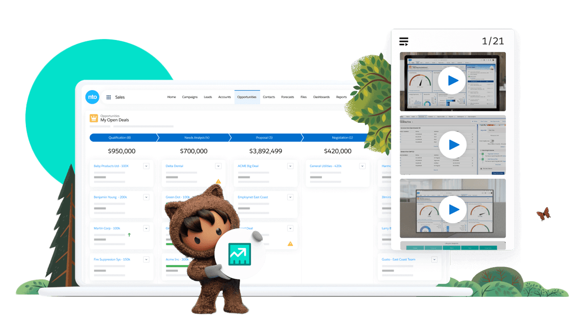

# By Siddi Hima Meghana [322103310214@gvpce.ac.in](mailto:322103310214@gvpce.ac.in)

1. **Project Overview**

This project, "**CRM Application for laptop rentals**" is focused on creating a Salesforce-based application to streamline laptop rental operations. By leveraging custom objects, validation rules, role-based access control, workflow automation, and reporting & dashboarding features within the Salesforce platform, the CRM provides a robust solution for managing the entire rental lifecycle. This comprehensive solution improves customer experience by ensuring timely communication and provides valuable insights for data-driven decision-making, ultimately driving business growth.

# Objectives

#### Business Goals:

* To optimize laptop rental operations by streamlining the entire rental process from booking to return.
* To increase revenue and profitability through effective inventory management.
* To build customer relationships by collecting valuable customer data and providing personalized service.

#### Specific Outcomes:

* **Real-Time Tracking**: Implement a dashboard to monitor laptop availability, rental bookings, customer interactions, and revenue generation.
* **Automation of Processes**: Streamline rental bookings and inventory management using Salesforce Flows and Triggers.
* **User-Friendly Interface**: Develop tabs for easy customer onboarding, rental requests, and staff access to relevant information.
* **Comprehensive Reporting**: Generate detailed reports to analyze rental trends, identify areas for improvement, and track key performance indicators.
* **Scalability**: Create a flexible and scalable platform that can accommodate a growing number of laptops, customers, and rental requests.

# Salesforce Key Features and Concepts Utilized

**Custom Objects and Fields:** Created tailored objects to manage laptop inventory, rental bookings, customer information, and payment details.

**Lightning App Builder:** Designed an intuitive and visually appealing Lightning app interface for users to easily navigate and manage rental requests, track inventory, and access customer information.

**Flows and Automation:** Implemented automation for rental bookings, payment processing, and inventory updates to improve efficiency.

**Triggers:** Developed Apex triggers to automate backend processes, such as updating inventory availability upon rental bookings or sending automated email notifications to customers.

**Reports and Dashboards:** Built dynamic dashboards and reports to provide real-time insights into rental trends, rental revenue etc.

# Detailed Steps to Solution Design

|  |  |
| --- | --- |
| **Topic no.** | **Topic Name** |
| 1 | **Creating objects:**   * 1. Create Total Laptops Object   2. Create consumer object   3. Create Laptop Bookings object   4. Create Billing process object |
| 2 | **Create Custom Tabs** |
| 3 | **Create Lightning App** |
| 4 | **Fields:**   * 1. Creating The Field In Consumer Object   2. Creating The Field In Laptop Bookings Object   3. To Create A Fields and Relationship To Laptop Bookings And Total Laptops Object   4. Creation of Fields and Relationship For Billing Process Object   5. Creating The Field In Total Laptops Object |
| 5 | **Validation Rule:** Creating The Validation Rule For Phone Number Field In Consumer Object |
| 6 | **Profiles:**   * 1. Owner Profile   2. Agent Profile |
| 7 | **Roles And Hierarchy:** Creating Owner Role |
| 8 | **Users:** Create User |

|  |  |
| --- | --- |
| **Topic no.** | **Topic Name** |
| 9 | **Flows:**   * 1. Create A Flow On Dell Laptop   2. Creating Flow On Acer Laptop   3. Creating A Flow On Hp Laptop   4. Creating A Flow On Mac Laptop |
| 10 | **Apex:** Apex Trigger And Handler Class |
| 11 | **Reports:**   * 1. Create Report   2. Sharing Report To Owner |
| 12 | **Dashboards:**   * 1. Create Dashboard Folder   2. Create Dashboard |

## Creating Objects

Objects in Salesforce are database tables that allow you to store data specic to your organization. Each object comprises records (rows) and elds (columns) that help organize and structure your data eciently. We use objects to manage and relate various types of information, enabling seamless data tracking, reporting, and analysis within the Salesforce platform. Objects allow users to manage various types of information such as customer accounts, contacts, opportunities, and custom data specic to the organization. Salesforce provides standard objects like Account, Contact, and Opportunity, and users can also create **custom objects** to suit unique business needs.

#### To create an object:

1. From the setup page > Click on Object Manager > Click on Create > Click on Custom Object.

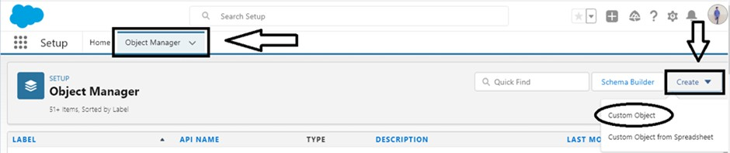

1. On Custom object defining page:
2. Enter the label name, plural label name, click on Allow reports, Allow search.

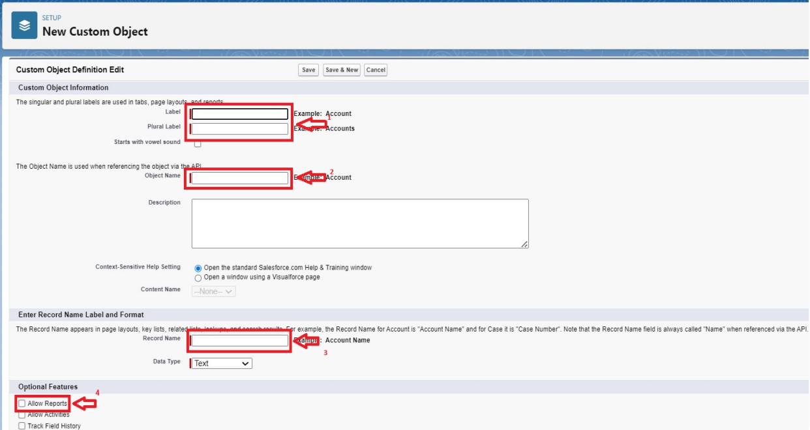

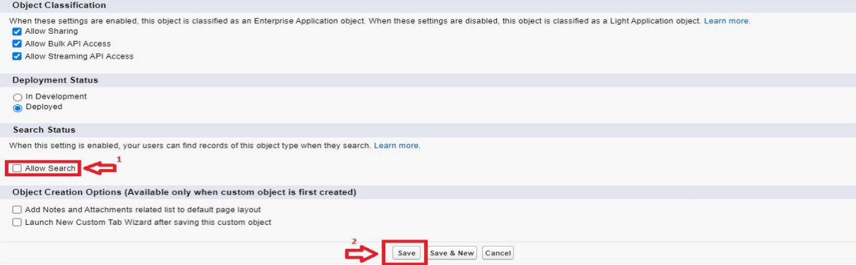

1. Click on Save.

#### Create Total Laptops Object

To Create an object:

* + 1. From the Setup page >> Click on Object Manager >> Click on create

>> Click on Custom Object.

* + - 1. Enter the label name >> Laptops
      2. Plural label name >> Laptops
      3. Enter Record Name Label and Format

Record Name >> Total Laptops Data Type >> Text

* + 1. Click on Allow reports, Allow search and Track Field History.
    2. Allow search >> Save

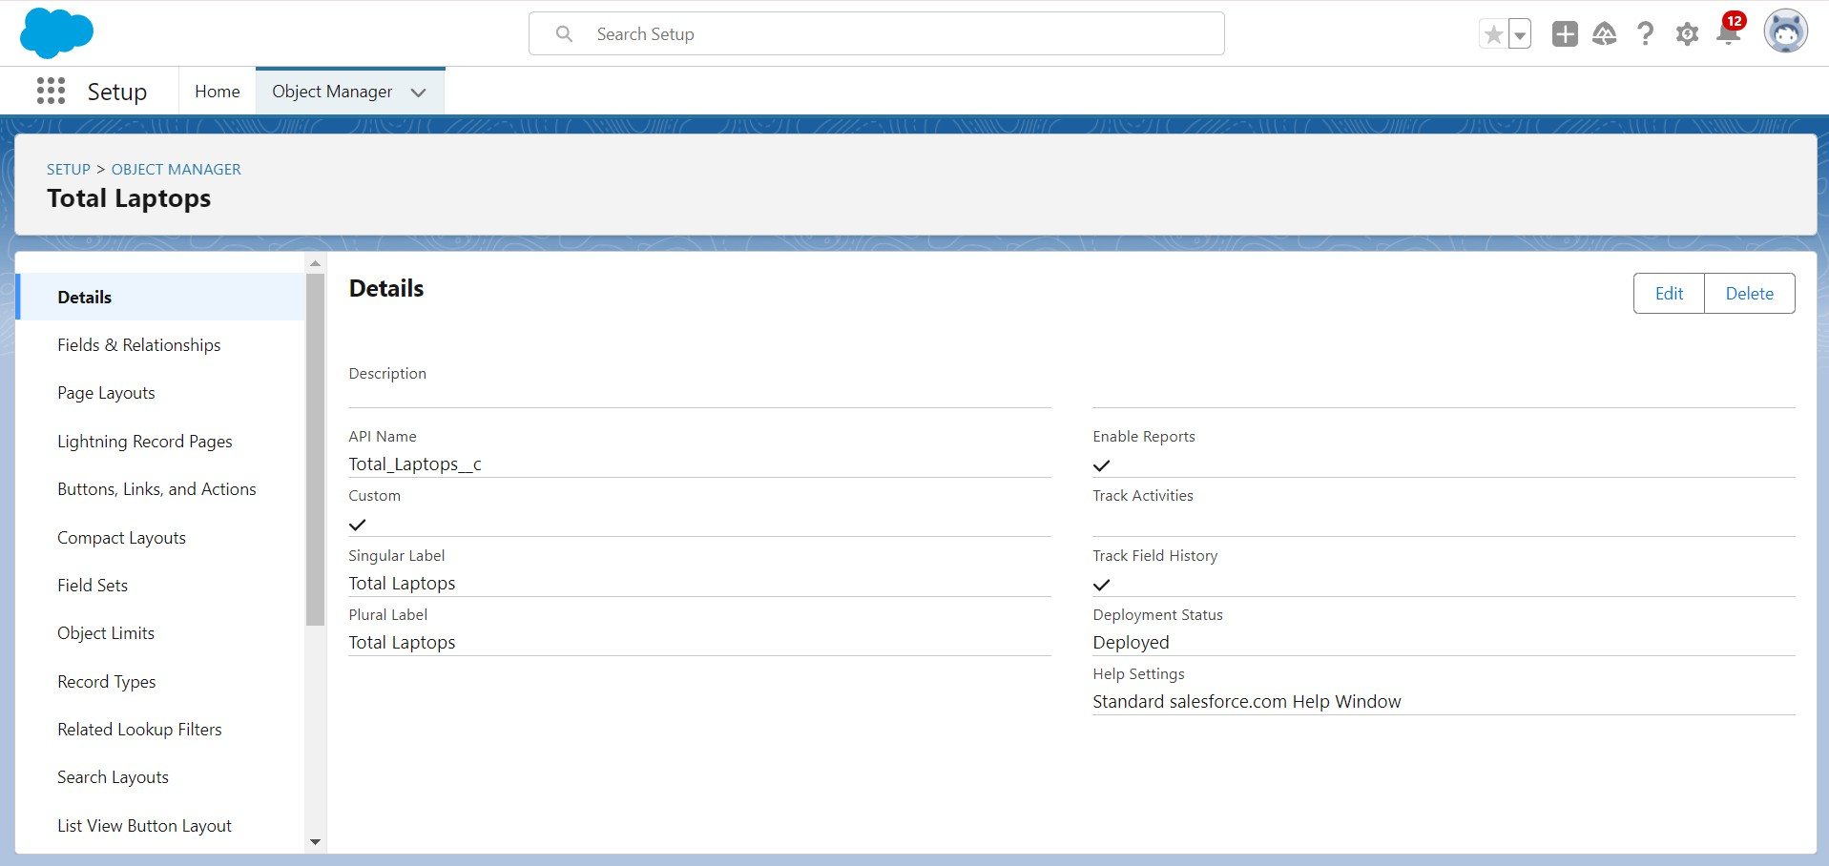

#### Create Consumer Object

To Create an object:

* + 1. From the Setup page >> Click on Object Manager >> Click on create

>> Click on Custom Object.

* + - 1. Enter the label name >> consumer
      2. Plural label name >> consumer
      3. Enter Record Name Label and Format Record Name >> consumer_name Data Type >> Name
    1. Click on Allow reports, Allow search and Track Field History.
    2. Allow search >> Save

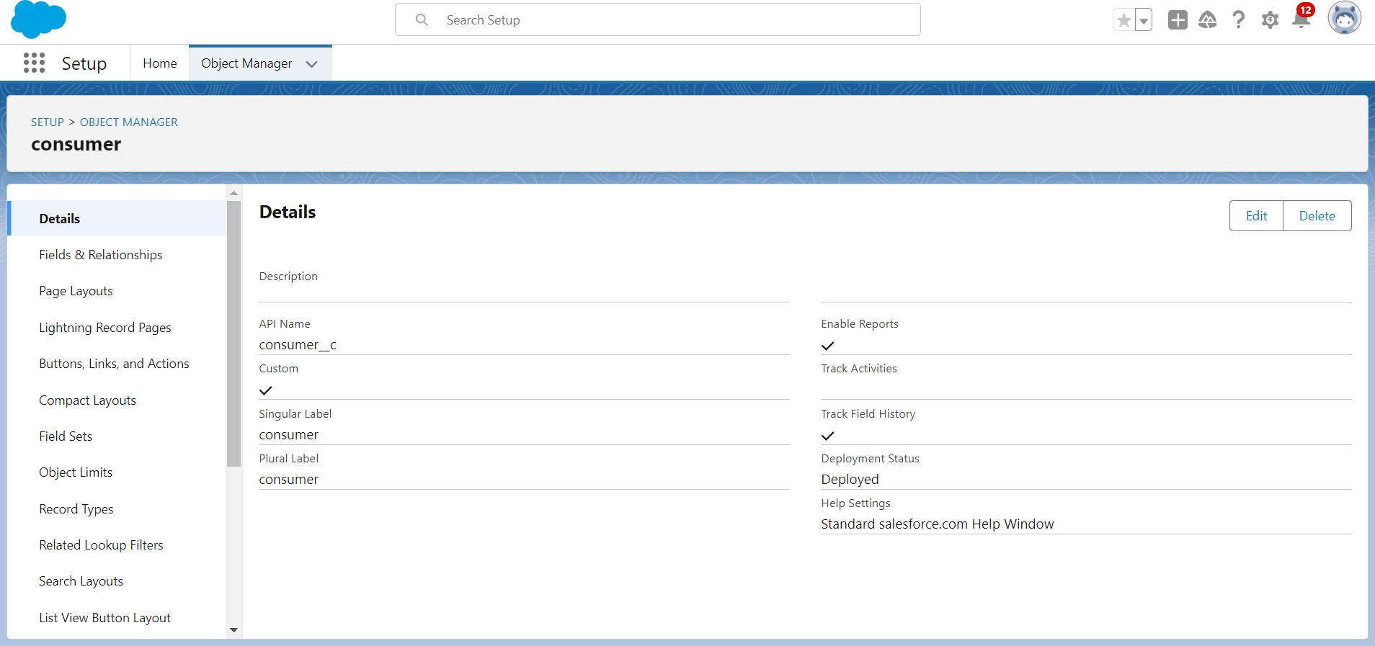

#### Create Laptop Bookings Object

To Create an object:

* + 1. From the Setup page >> Click on Object Manager >> Click on create

>> Click on Custom Object.

* + - 1. Enter the label name >> Laptop Bookings
      2. Plural label name >> Laptop Bookings
      3. Enter Record Name Label and Format Record Name >> Laptop Bookings Data Type >> Name
    1. Click on Allow reports, Allow search and Track Field History.
    2. Allow search >> Save

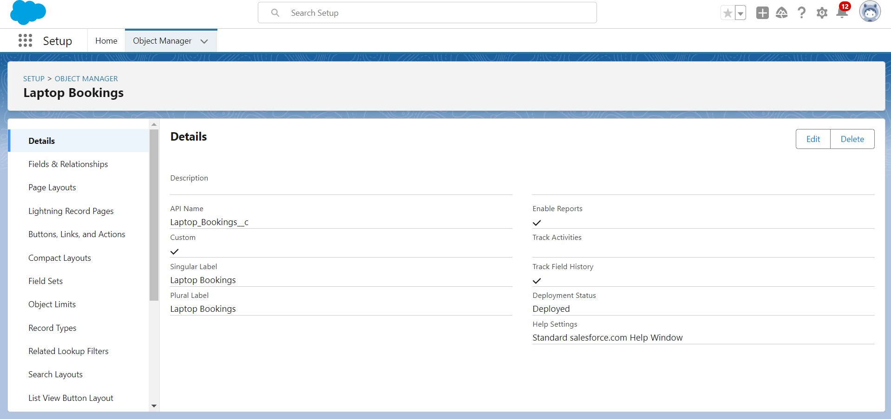

#### Create Billing Process Object

To Create an object:

* + 1. From the Setup page >> Click on Object Manager >> Click on create

>> Click on Custom Object.

* + - 1. Enter the label name >> Billing Process
      2. Plural label name >> Billing Process
      3. Enter Record Name Label and Format Record Name >> Billing ProcessName Data Type >> Name
    1. Click on Allow reports, Allow search and Track Field History.
    2. Allow search >> Save

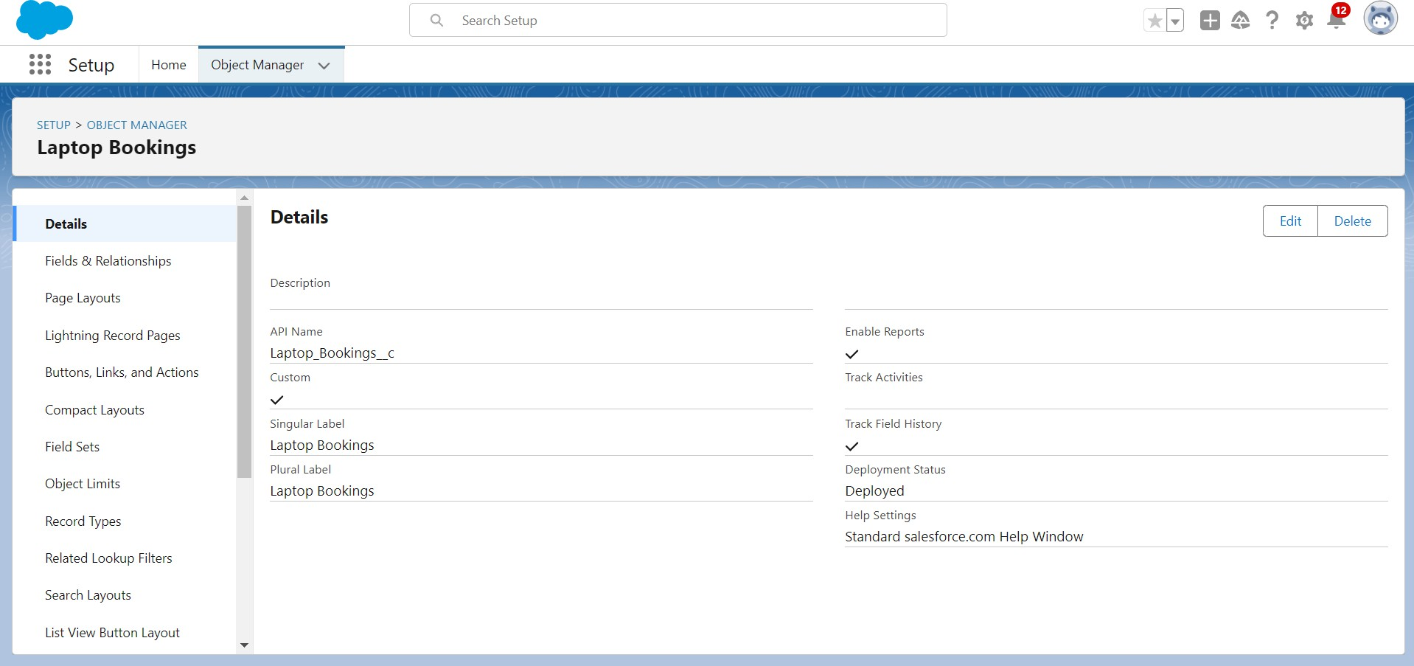

## Creating Tabs

A **tab** is a user interface component that helps users organize, access, and manage records of different **objects** within the platform. Salesforce objects represent different types of data, such as Accounts, Contacts, Opportunities, or Custom Objects, and each object has its own tab. Here's a more detailed explanation of what a tab is and how it functions.

#### Creating Total Laptops Tab:

To create a Tab:

* + - 1. Go to setup page >> type Tabs in Quick Find bar >> click on tabs >> New (under custom object tab)

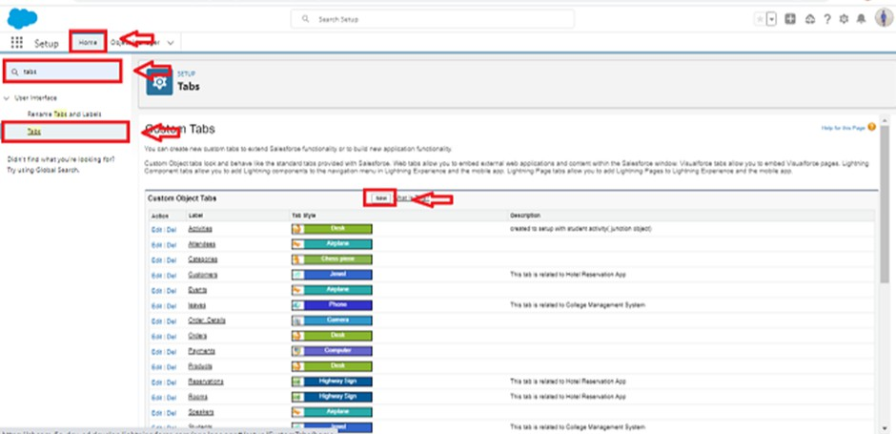

* + - 1. Select Object(Total Laptops) >> Select the tab style >> Next (Add to profiles page) keep it as default >> Next (Add to Custom App) uncheck the include tab .
      2. Make sure that the Append tab to users' existing personal customizations is checked.
      3. Click save.

#### Creating Remaining tabs:

* + - 1. Now create the Tabs for the remaining Objects, they are “consumer,Laptop Booking,Billing process”.
      2. Follow the same steps as 2.1 .

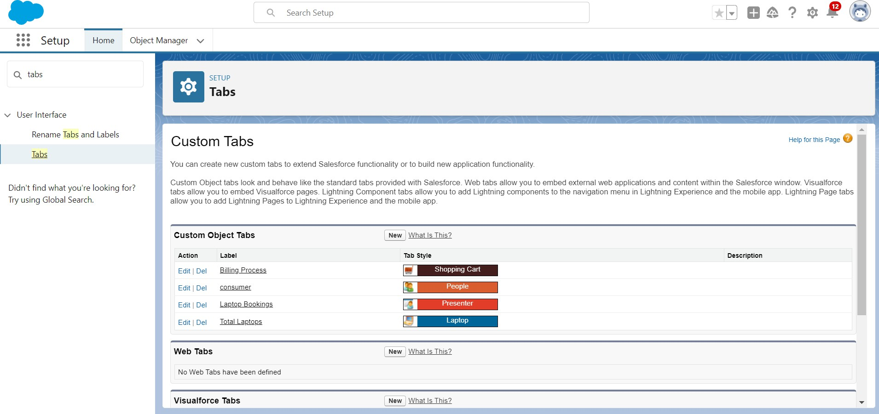

## Create Lightning App

#### To Create a Lightning app page:

1. Go to setup page >> search “app manager” in quick nd >> select “app manager” >> click on New lightning App.

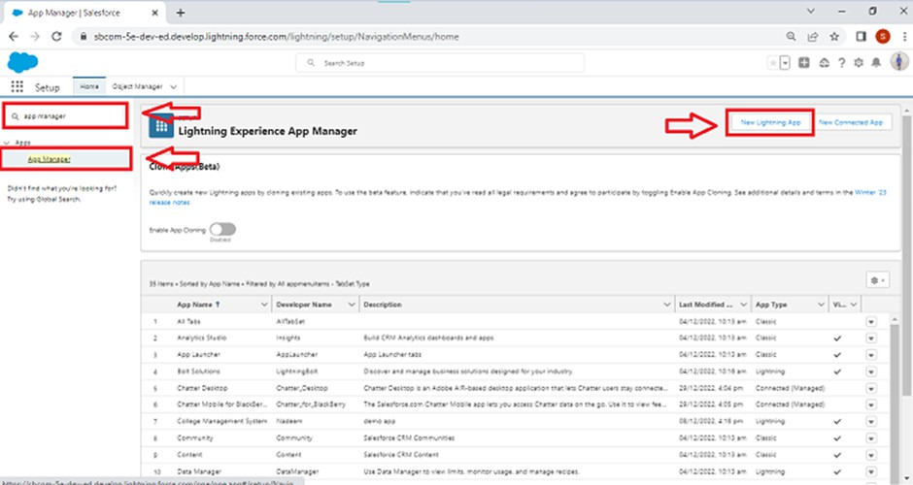

1. Fill the app name in app details as LAPTOP RENTALS >>Next >> (App option page) keep it as default >> Next >> (Utility Items) keep it as default >> Next.
2. Upload a photo that is related to your app.
3. To Add Navigation Items:

Select the items (Total Laptops,consumer,Laptop Booking,Billing Process) from the search bar and move it using the arrow button >> Next.

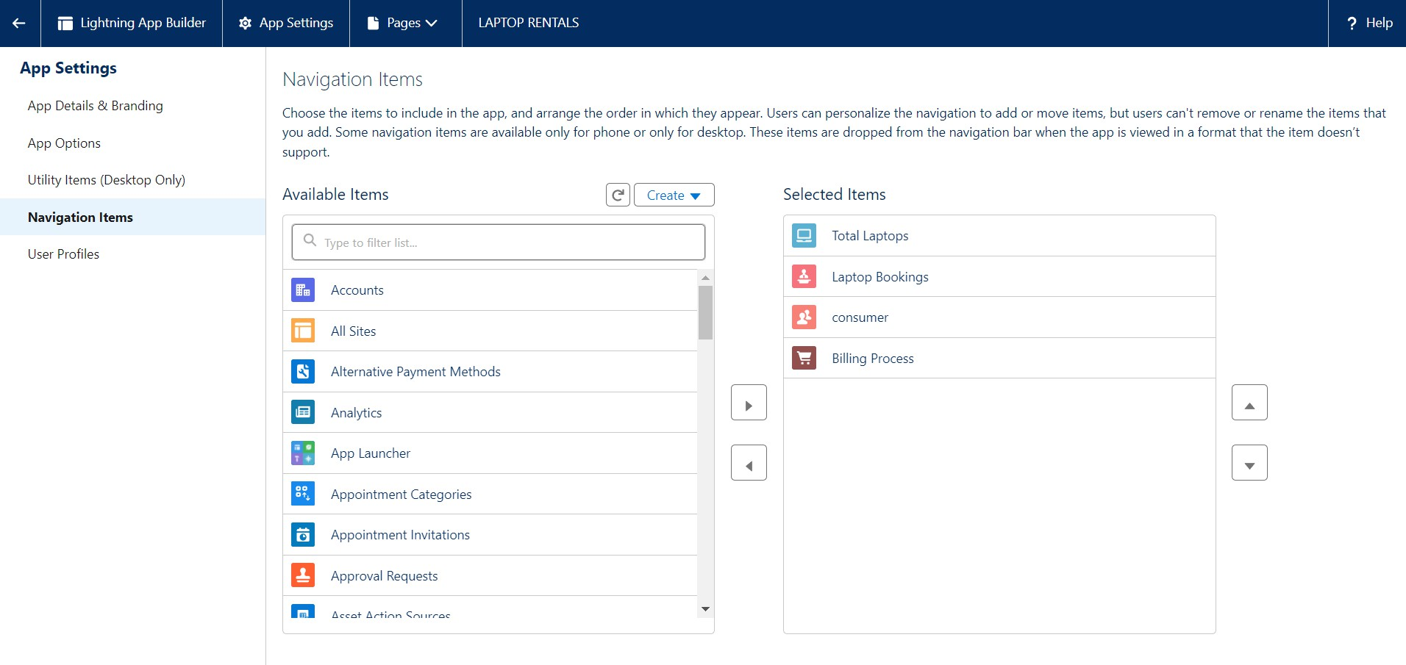

1. To Add User Profiles:

Search profiles (System administrator) in the search bar >> click on the arrow button >> save & finish.

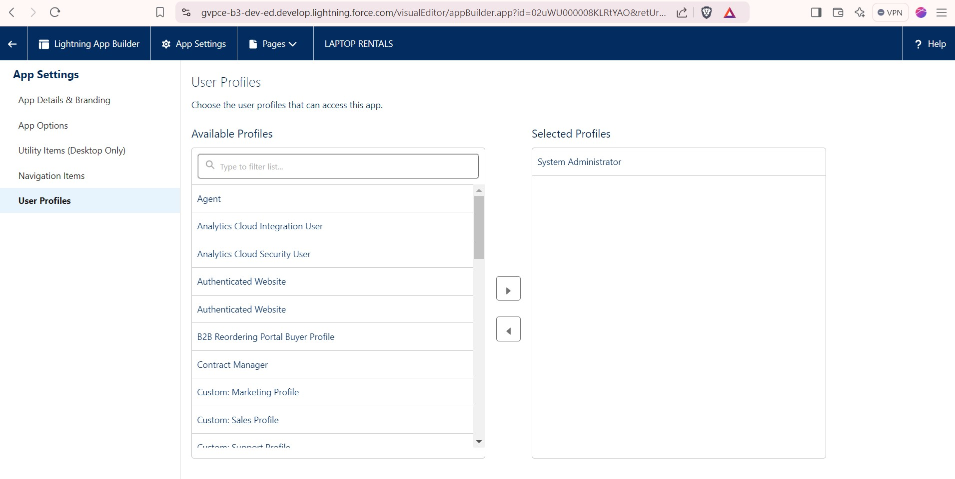

## Fields

Fields are fundamental building blocks of objects. They store individual pieces of data in a record and define the data type, behavior, and purpose of that data. Fields are associated with both **standard** and **custom objects**. Fields in Salesforce are data containers within objects that store specic pieces of information, such as text, numbers, or dates.

#### Steps to Create Field For a Object:

1. Go to setup >> click on Object Manager >> type object name in search bar >> click on the object.
2. Now click on “Fields & Relationships” >> New
3. Select Data Type and fill details like label, name, etc.
4. Click on Next >> Next >> Save and new.

#### Creating The Fields In Consumer Object

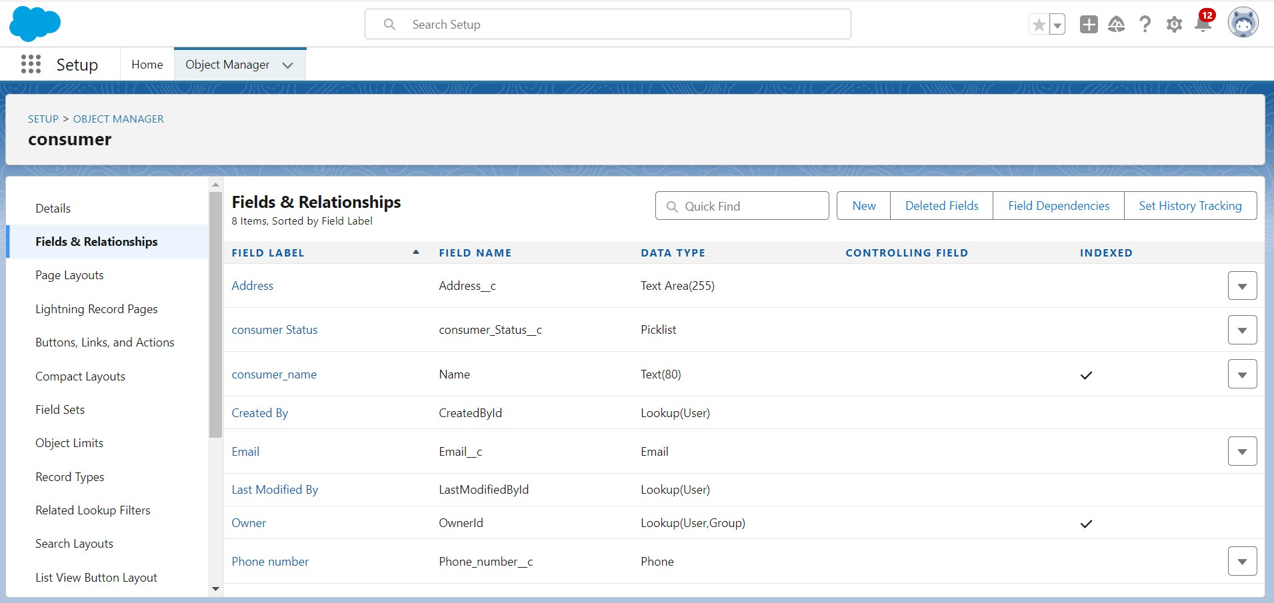

* + 1. Create Phone number field:
* Select Data Type as a “Phone” and click on next.
* Field Label: Phone number
* Field Name : gets auto generated
* Click the required option checkbox.
  + 1. Create Email field:
* Select Data Type as a “Email” and click on next.
* Field Label: Email
* Field Name : gets auto generated
  + 1. Create Address field:
* Select Data Type as a “Text Area” and click on next.
* Field Label: Address
* Field Name : gets auto generated
  + 1. Create Consumer status field:
* Select Data Type as a “Picklist” and click on next.
* Field Label: consumer Status
* Value - Select enter values with each value separated by a new line

1.Student 2.Employee 3.Others

* Select required Field Name :It’s gets auto generated

#### Creating The Fields In Laptop Bookings Object

* + 1. Create Laptop Names field:
* Select Data Type as a “Picklist” and click on next.
* Field Label: Laptop Names
* Picklist values are: 1.Dell 2.Acer 3.Hp 4.Mac
* Field Name : gets auto generated
  + 1. To create Core Type field:
* Select Data Type as a “Picklist” and click on next.
* Field Label: Core Type
* Picklist values are: core i3, core i5, core i7, Bionic chip
* Select Required
  + 1. To create field dependency in the Laptop Booking Object:
* Click field dependency and next.
* Select Controlling Field as Laptop Names and Dependent Field as Core Type
* Click the include value for dell-core i3,i5,i7 and for acer i3,i5,i7 and for hp i3,i5,i7 and also for mac bionic chip include the values for it.

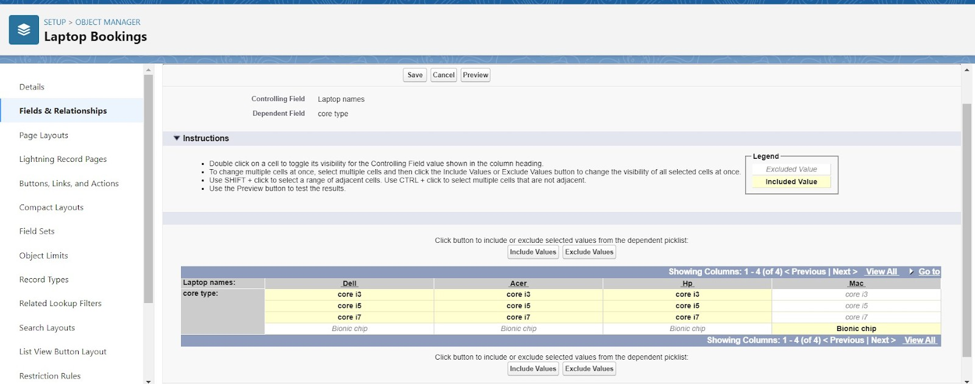

#### To Create a Fields & Relationship to an Laptop Booking and Total Laptops Objects

1. Create "Master-detail Relationship" in Laptop Booking Object:
   * Go to setup >> click on Object Manager >> type object name(Laptop Booking) in the search bar >> click on the object.
   * Now click on “Fields & Relationships” >> New Select Data Type as a “Master-Detail Relationship” and Click on Next.
   * Click on the Related to drop down and Select the “consumer” object

and click on Next

* + Fill the Above as following: Change the Field Label: Consumer

Field Name :It’s gets auto generated

* + Click on Next >> Next >> Save and new.

1. Create "Currency" field
   * Field Label: Amount
   * Length: (18,0)
   * Field Name :It’s gets auto generated
   * Click on Next >> Next >> Save and new
2. Create relationship to "Total Laptops" object
   * Select Laptop booking object in the object manager.
   * Now click on “Fields & Relationships” >> New
   * Select Data Type as a “Lookup Relationship” and Click on Next
   * Click on the Related to drop down and Select the “Total Laptops” object and click on Next
   * Change the Field Label: Total No Of Laptops
   * Field Name :It’s gets auto generated
   * Click on Next >> Next >> Save and new.
3. Create Email field in Laptop Bookings Object
4. Create "Rollup Summary" in Total Laptops Object
   * Field Label: Laptops delivered
   * Field Name :It’s gets auto generated
5. Select the Laptop Bookings in the Summarized Object
6. Select the count Radio button in the select Roll-up Type

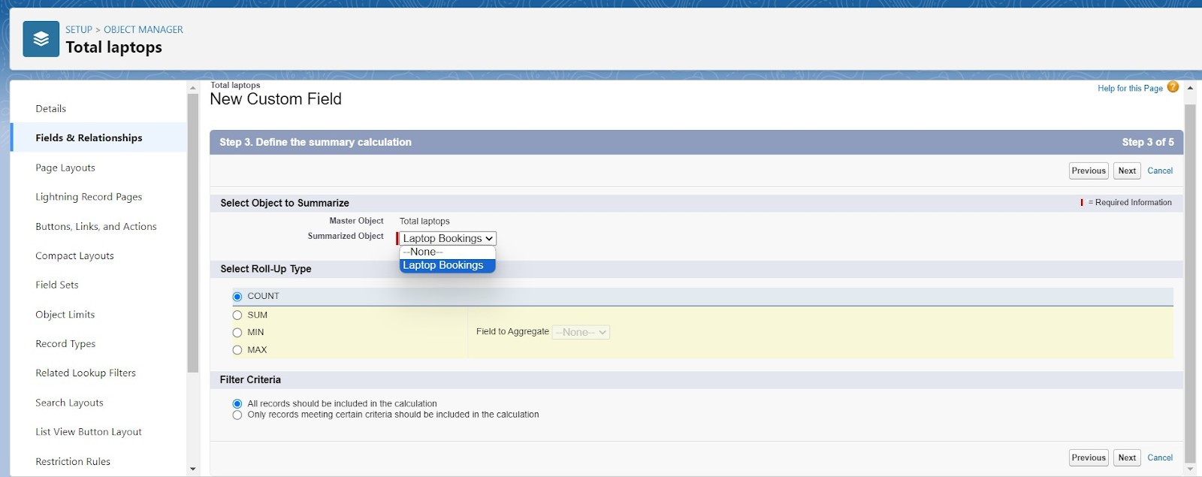

1. Create "Laptops Available" field:
   * Field Label: Laptops Available
   * Field Name : It’s gets auto generated
   * Select the Formula Return Type as “Number”
   * Select the Decimal places as “0” and Click on Next
   * Click on the Advanced Formula and Enter the value in formula box "50 - Total_no_of_laptops r.Laptops_delivered c"
2. Create "how many months" field in Laptop Bookings object:
   * Label: how many months
   * Picklist values are: 1, 2, 3, 4, 5

#### Creation of Fields & Relationship for Billing Process Object

1. Create relationship for consumer object:
   * Now click on “Fields & Relationships” >> New in Billing Process object
   * Select Data Type as a “Master-detail Relationship”
   * Click on Next Click on the Related to drop down and Select the consumer object and click on Next
   * Click on the Related to drop down and Select the consumer object and click on Next
   * Change the Field Label: Name and click on save and new

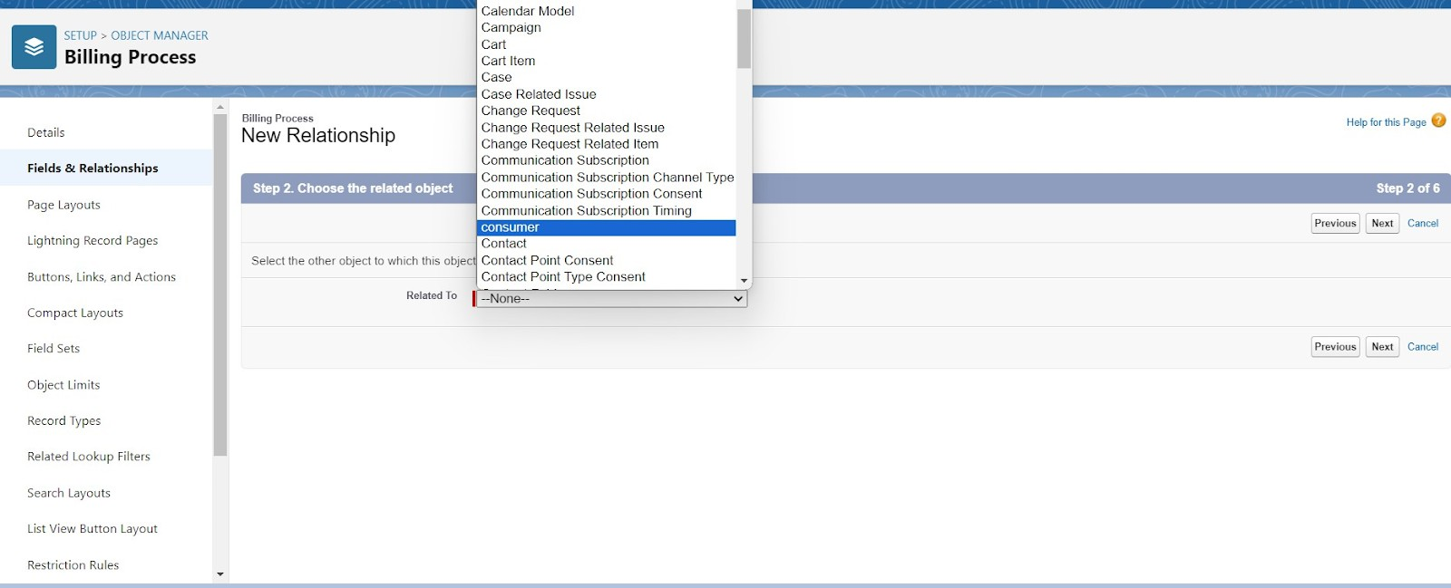

1. Create "Lookup Relationship" in Laptop Booking object
2. Create "Payment Mode" as picklist values (Cash, Check, Credit card, Debit card, UPI, Phonepe, Gpay, Paytm)
3. Create a Cross object formula Field in billing process Object:
   * Select Data Type as a “Formula” and Click on Next
   * Enter the Field label: Amount

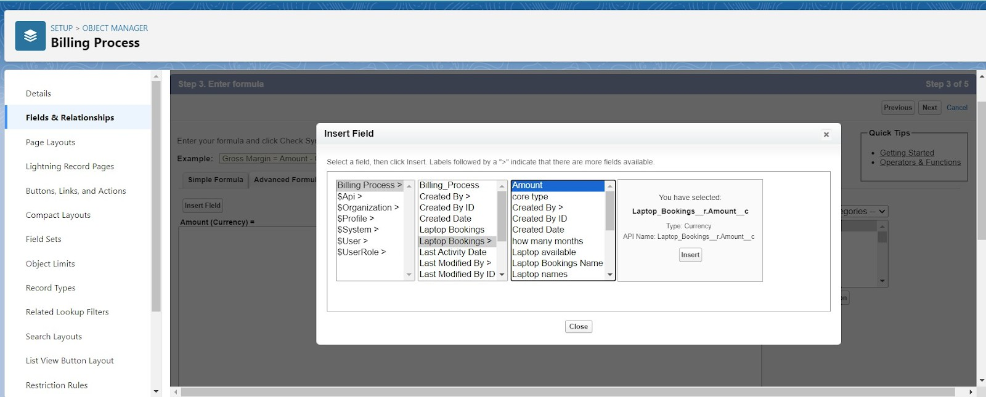

* + formula: “ Laptop_Booking r.Amount c ”

#### Creating the field in Total Laptops object

* Go to setup >> click on Object Manager >> type object name(Total Laptops) in search bar >> click on the object.
* Now click on “Fields & Relationships” >> New Select Data type as a “Formula” and Click on Next
* Field Label: Laptops Available Field Name : It’s gets auto generated Select the Formula Return Type as “Number”

## Validation Rule

Validation rules are applied when a user tries to save a record and are used to check if the data meets **specified criteria**. If the criteria are not met, the validation rule triggers an error message and prevents the user from saving the record until the issues are resolved.

1. Go to the setup page >> click on object manager >> From drop down click edit for consumer object.
2. Click on the validation rule >> click New.

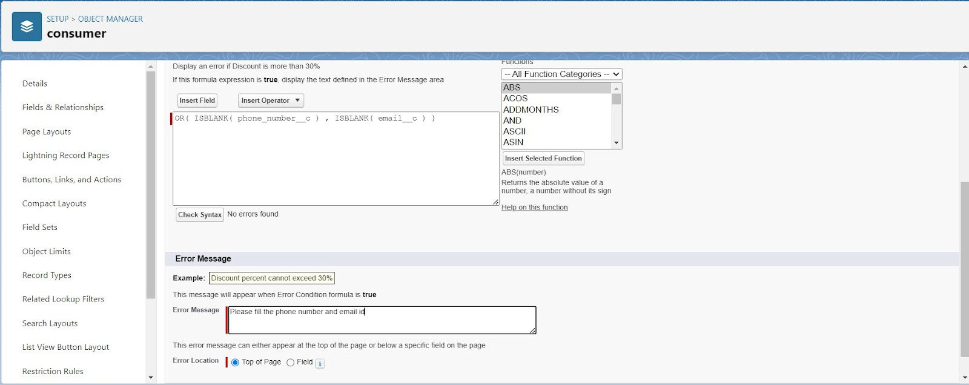

1. Enter the Rule name as “Phonenumberoremailblankrule ”.
2. Enter the description as “phone number and email number should not be blank”.
3. Enter the formula as “**OR( ISBLANK( phone_number__c ) , ISBLANK( email__c ) )**” and check the syntax.

## Profiles

A profile is a group/collection of settings and **permissions** that define what a **user** can do in salesforce. Profile controls “Object permissions, Field permissions, User permissions, Tab settings, App settings, Apex class access, Visualforce page access, Page layouts, Record Types, Login hours & Login IP ranges.

#### Create Owner Profile

* + 1. Go to setup >> type profiles in quick find box >> click on profiles >> clone the desired profile (Standard User) >> enter profile name (owner) >> Save.

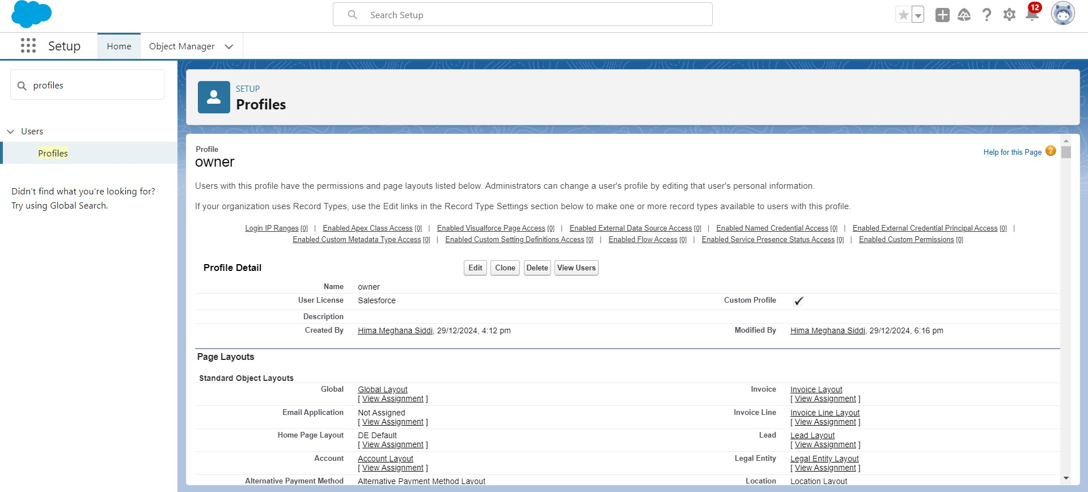

* + 1. Scroll down to Custom Object Permissions and Given access permissions for Total Laptops, consumers, Laptop Booking and Billing Process objects as mentioned in the below diagram.

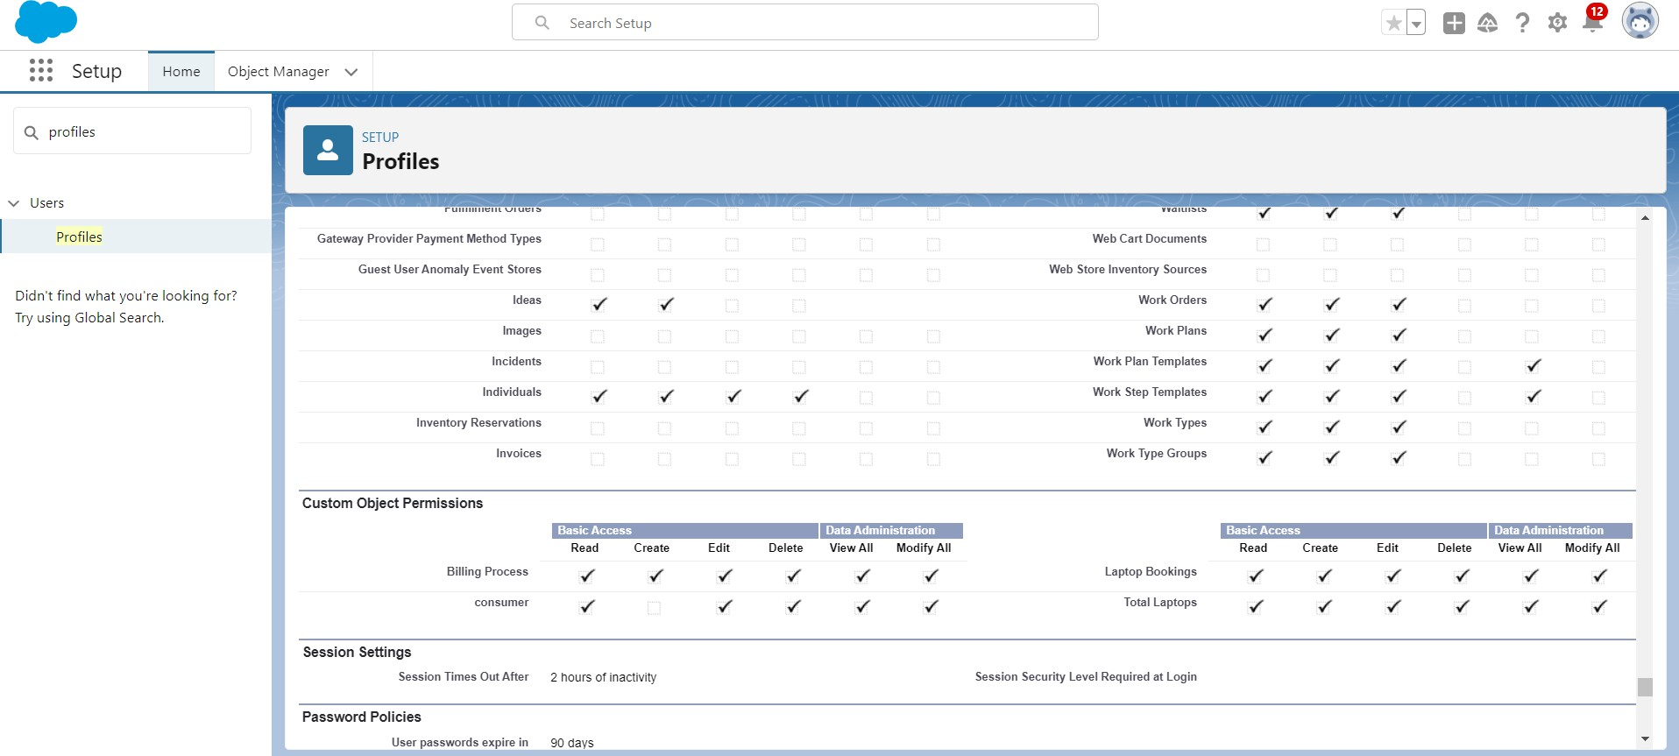

#### Create Agent Profile

* + 1. Go to setup >> type profiles in quick find box >> click on profiles >> clone the desired profile (Standard Platform User) >> enter profile name (Agent) >>Save.
    2. 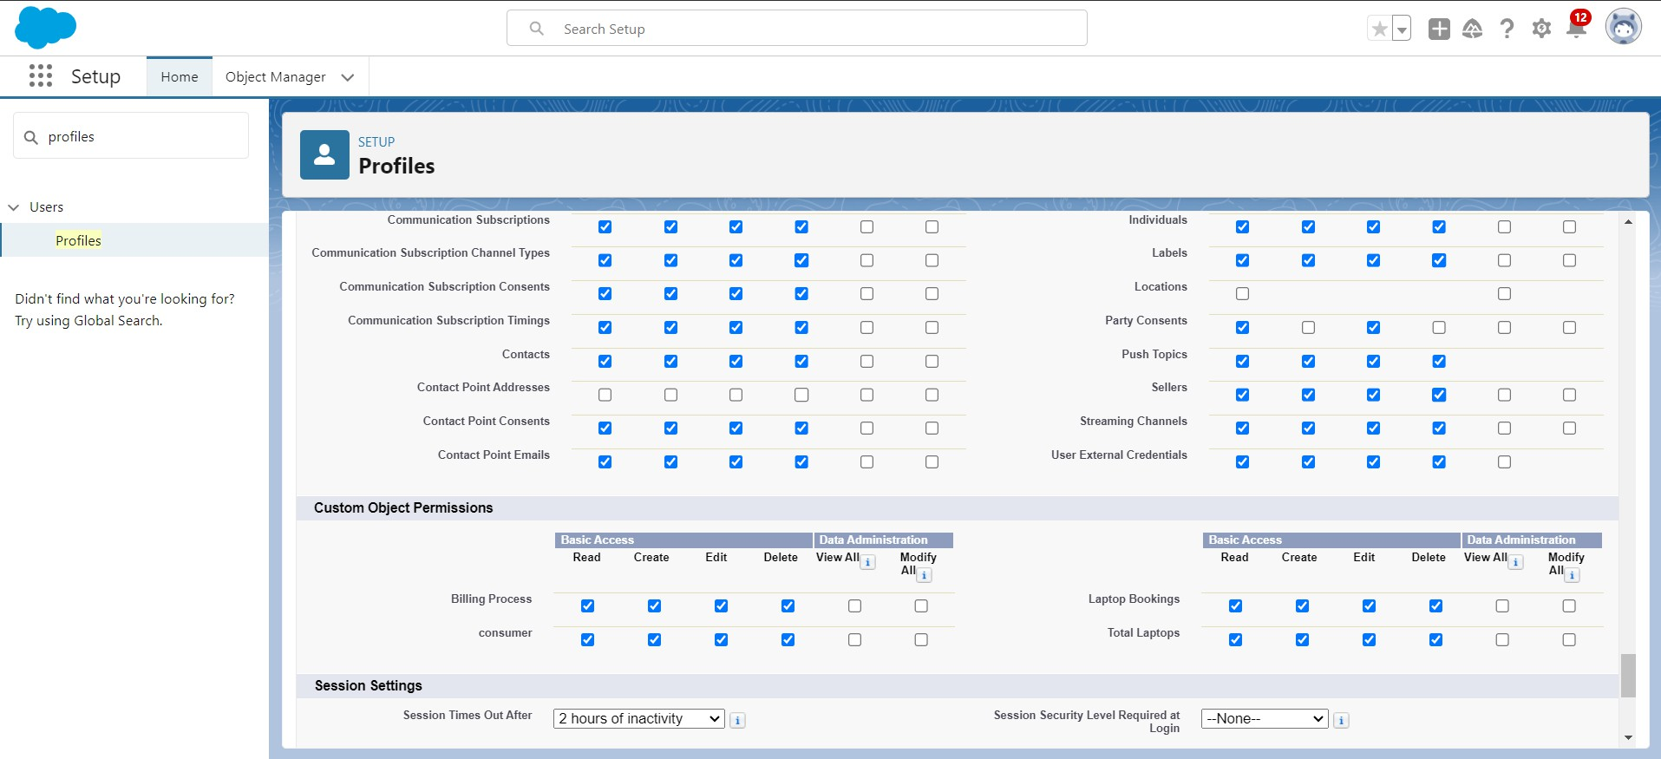Scroll down to Custom Object Permissions and Given access permissions for Total Laptops, consumer , Laptop Bookings and Billing Process objects as mentioned in the below diagram.

## Roles and Hierarchy

A role in Salesforce defines a **user's visibility access** at the record level. Roles may be used to specify the types of access that people in your Salesforce organization can have to data.

#### Steps:

1. Go to quick find >> Search for Roles >> click on set up roles.
2. Click on Expand All and click on add role under whom this role works.

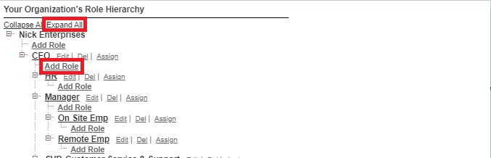

#### Create Owner role

* + 1. Give Label as “owner” and Role name gets auto populated. Then click on Save.

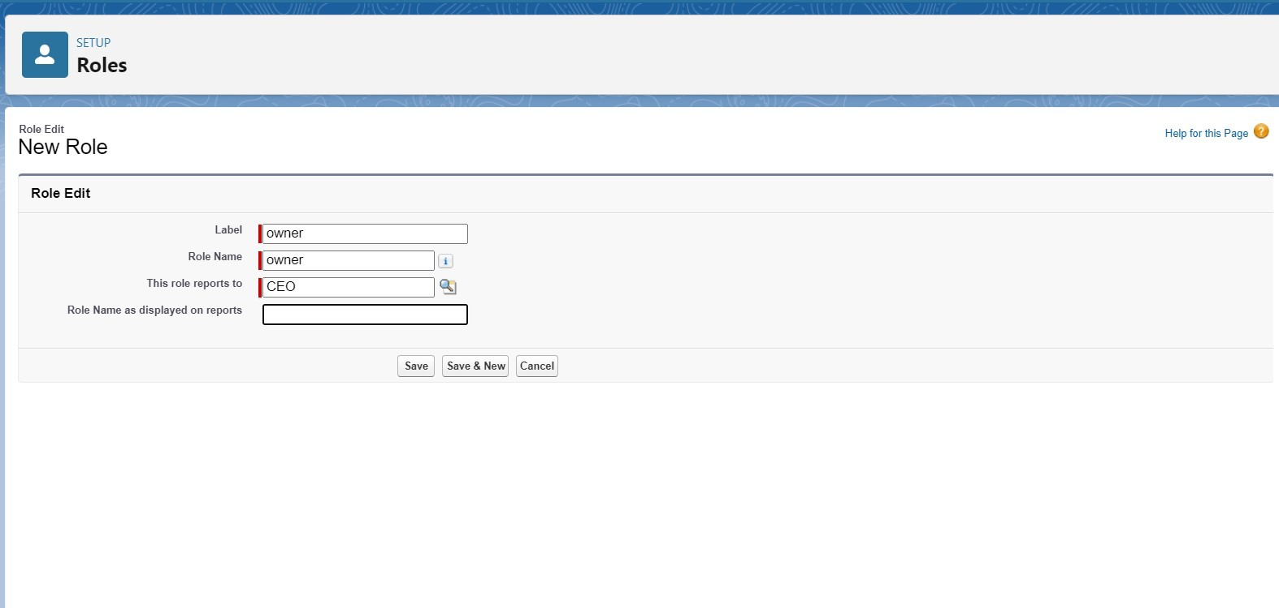

* + 1. Click and save it.

#### Create Agent Role

* + 1. Go to quick find - Search for Roles - click on set up roles.
    2. Click plus on CEO role, and click add role under owner.
    3. Give Label as “Agent” and Role name gets auto populated. Then click on Save.

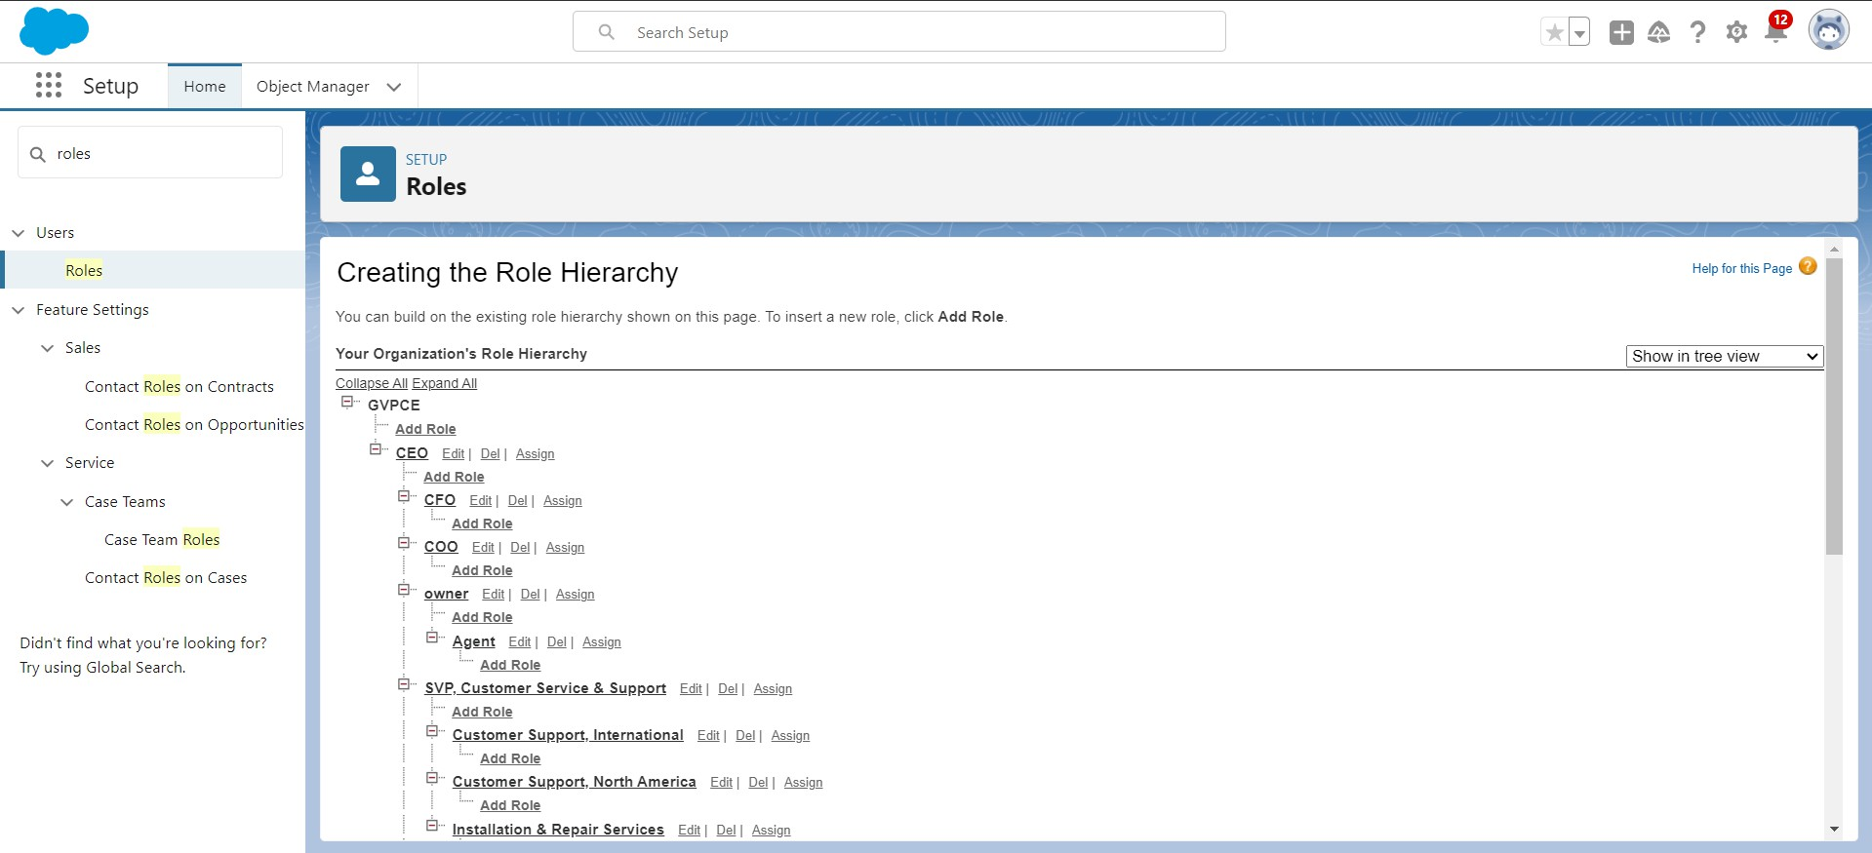

## Users

A user is anyone who **logs in** to Salesforce. Users are employees at your company, such as sales reps, managers, and IT specialists, who need access to the company's records. Every user in Salesforce has a user account. The user account identifies the user, and the user account settings determine what **features** and **records** the user **can access**.

#### Create User

1. Go to setup - type users in quick find box - select users -click New user.
2. Fill in the fields
   * First Name : vicky
   * Last Name : y
   * Alias : Give a Alias Name
   * Email id : Give your Personal Email id
   * Username : Username should be in this form: [text@text.text](mailto:text@text.text)
   * Nick Name : Give a Nickname
   * User license : Salesforce
3. If the user is
   * "owner": Set the profiles and role field to owner
   * "Agent": Set the profiles and role field to Agent

## Flows

"flows" typically refer to Salesforce Flow, which is a powerful automation tool that allows you to create **custom**, **automated** processes in your Salesforce org without writing code. Flow is a point-and-click tool that enables you to design and automate **complex business processes**, collect data, and interact with users in a visual interface.

#### Create a Flow on dell laptop

* + 1. Go to setup >>type Flow in quick find box >> Click on the Flow and Select the New Flow.

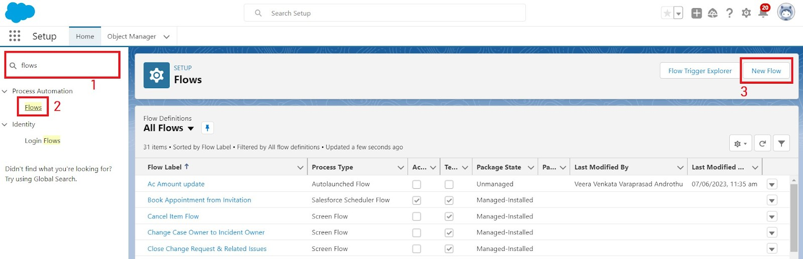

* + 1. Select the Record-triggered flow and Click on Create.
    2. Select the Object as a Laptop Booking in the Drop down list.
    3. Select the Trigger Flow when: “A record is Created or Updated”.
    4. Select the Optimize the flow for: “Actions and Related Records” and Click on Done.

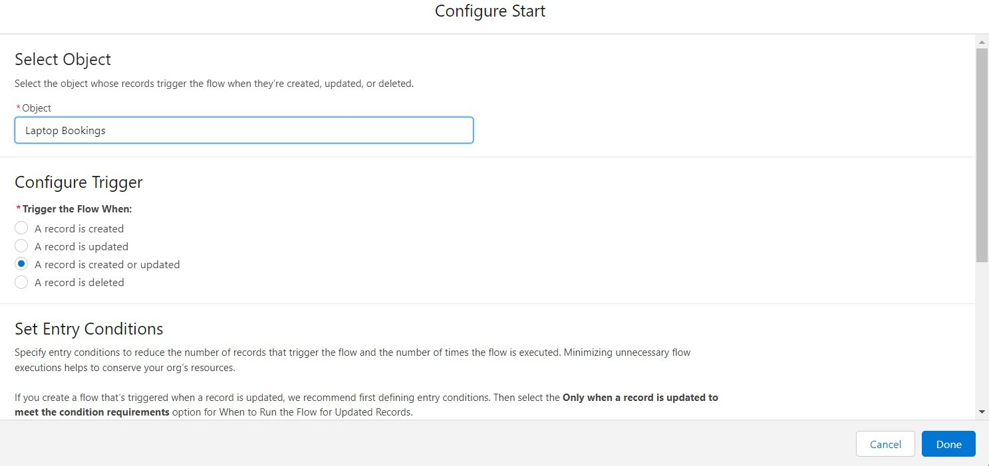

1. Under the Record-triggered Flow Click on “+” Symbol and In the Drop down List select the “Decision Element”.
2. Enter the Details Label: Field should be Update, API name: Gets Automatically Generated.
3. Enter the Outcome Details Label: dell , Outcome API name: Gets Automatically Generated.
   * Resource: Select $Record.Laptop_name c.
   * Operator: Select Equals.
   * Value: Select dell Add the same outcome order to acer , hp, mac.
   * Rename Default outcome as False
   * Click done.
4. Beside dell there is a symbol ‘+’ click on that. Again select decision
5. Enter the Details Label: Field should Update(any one u want), API name: Gets Automatically Generated.
6. Select the Outcome Details Label: dell core i3 , Outcome API name:

Gets Automatically Generated. Resource: Select

{!$Record.core_type c}. Operator: Select Equals. Value: Select core i3.

1. Add the dell i5 and dell i7 outcome details in the similar way
2. So go to the flow page select ‘+’ after core i3 then again select the decision.
3. Enter the Details Label: months selected , API name: Gets Automatically Generated.
4. Enter the Outcome Details Label: dell 1(i3) , Outcome API name: Gets Automatically Generated.
   * Resource: Select Record.how many months
   * Operator: Select Equals
   * Value: 1
5. Similarly Enter the OutcomeDetails as
   * dell 2(i3) -> resource: Record.how many months , value: 2
   * dell 3(i3) -> resource: Record.how many months , value: 3
   * dell 4(i3) -> resource: Record.how many months , value: 4
   * dell 5(i3) -> resource: Record.how many months , value: 5
6. Enter the Details Label: one month of dell i3 rate , API name: Gets Automatically Generated. Enter label name in a similar way for other update records.
7. Field:- Amount c , value:- for dell 1(i3)-1000, dell 2(i3)-2000, dell 3(i3)-3000, dell 4(i3)-4000, dell 5(i3)-5000. Follow all these finally and update the Amount field value based on the number of months.
8. Perform these steps for core i5 and i7.
9. Click done.

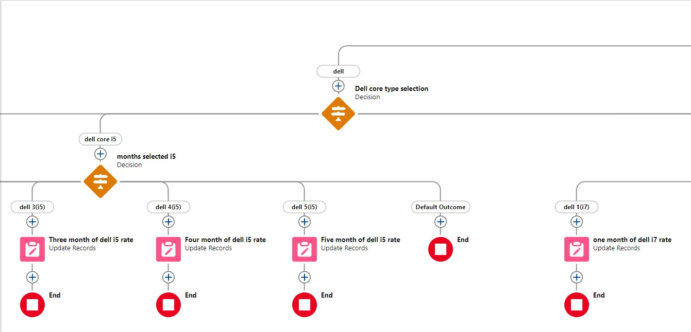

#### Create A Flow on Acer Laptop

* + 1. Enter the Details Label: Acer core type selection, API name: Gets Automatically Generated.
    2. Select the Outcome Details Label: acer core i3 , Outcome API name: Gets Automatically Generated.
* Resource: Select Record.core type.
* Operator: Select Equals.
* Value: Select core i3.
  + 1. Similarly create outcomes for acer core i5 and acer core i7 also.

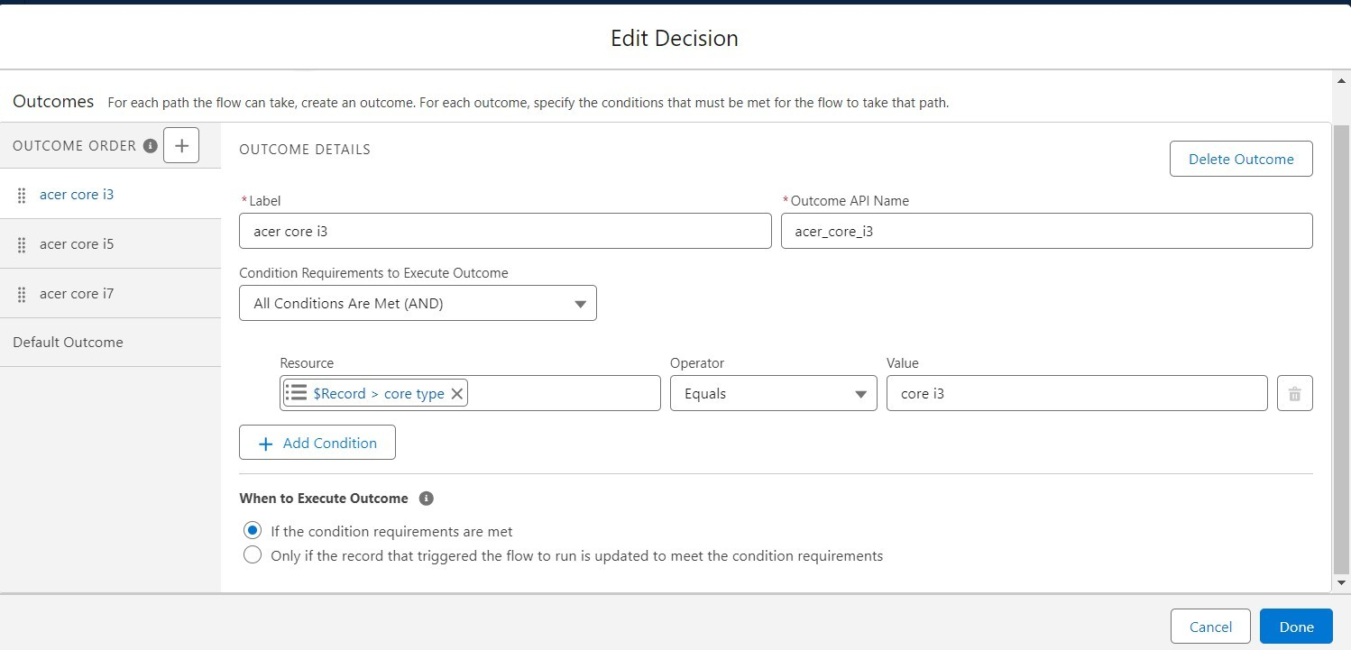

* + 1. Create Outcome Details Labels: acer 1(i3), acer 2(i3), acer 3(i3), acer 4(i3), acer 5(i3)

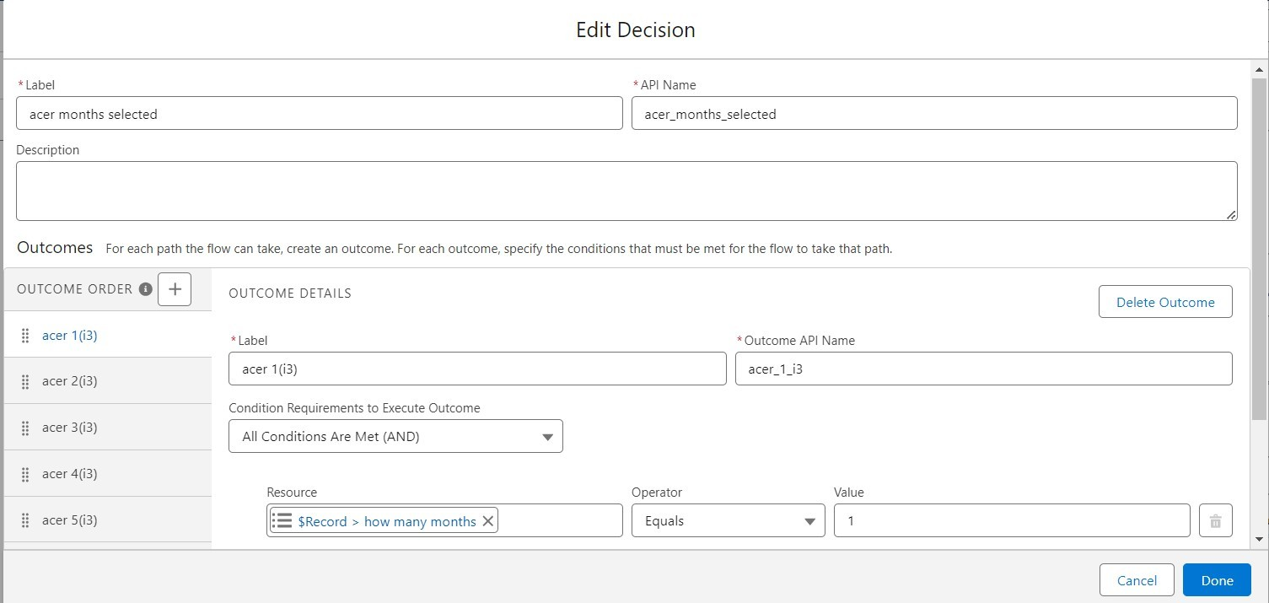

* + 1. Enter the Details Label: one month of acer i3 rate , API name: Gets Automatically Generated.
    2. Field:- Amount c , value:- for acer 1(i3)-900, acer 2(i3)-1800, acer 3(i3)-2700, acer 4(i3)-3600, acer 5(i3)-4800.
    3. Perform these steps for core i5 and i7.
    4. Click done.

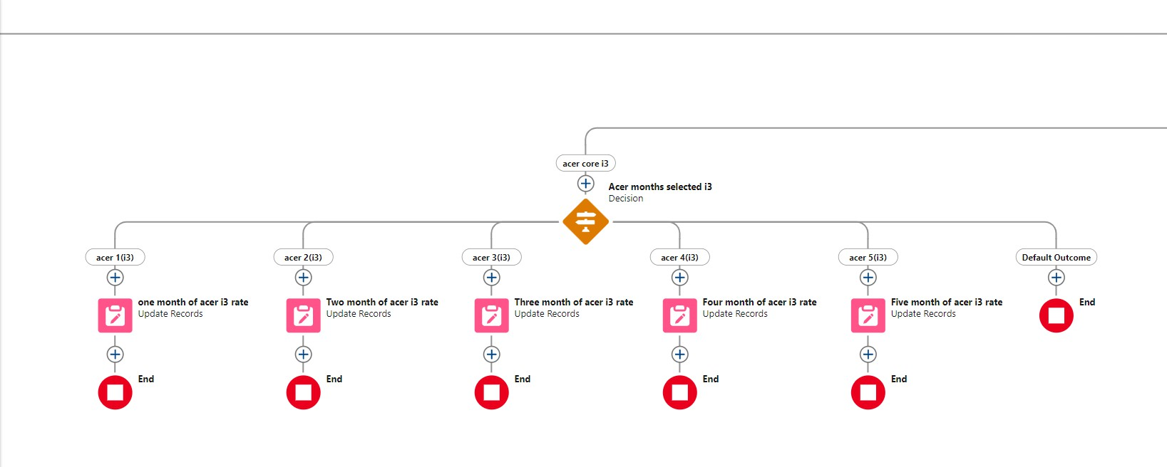

#### Create A Flow On Hp Laptop

1. Go to flow page
2. Beside hp there is a symbol ‘+’ click on that.
3. Enter the Details Label: HP core selection, API name: Gets Automatically Generated.
4. Select the Outcome Details Label: hp core i3 , Outcome API name: Gets Automatically Generated.

* Resource: Select Record.core type.
* Operator: Select Equals.
* Value: Select hp i3.

1. Similarly create outcomes for hp core i5 and hp core i7 also.

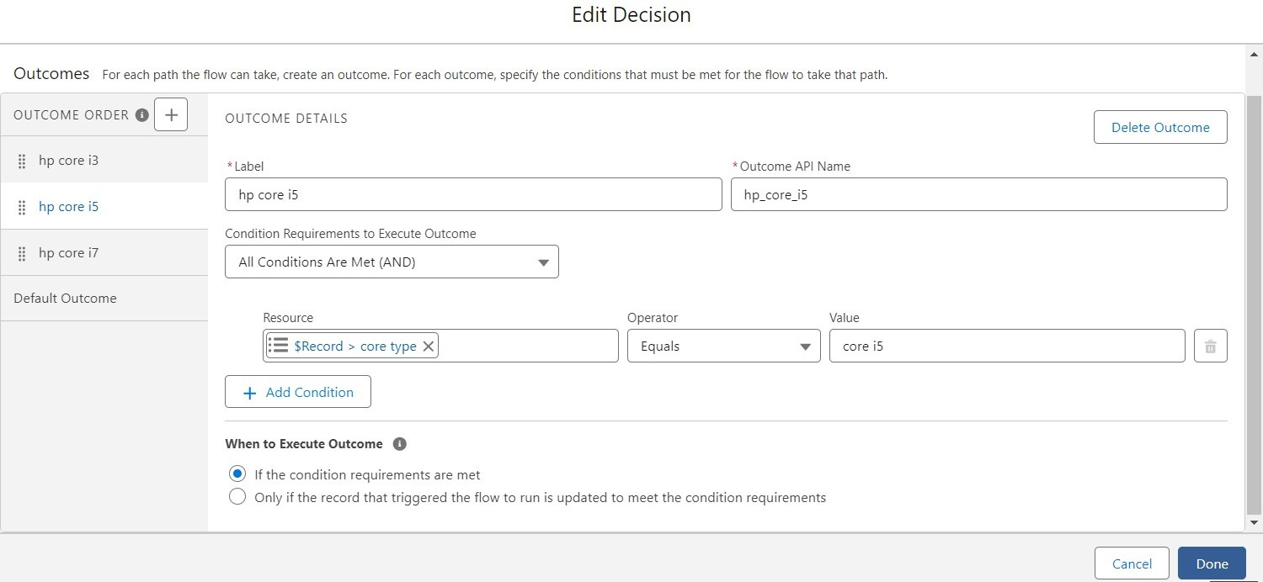

1. Beside hp there is a symbol ‘+’ click on that.
2. Enter the Details Label: hp core i5 month selection , API name: Gets Automatically Generated. Enter the Outcome Details Label: hp 1(i3) , Outcome API name: Gets Automatically Generated.

* Resource: Select Record.how many months.
* Operator: Select Equals.
* Value: 1.

1. Similarly Create Outcome Details Labels: hp 2(i3), hp 3(i3), hp 4(i3), hp 5(i3).
2. Field:- Amount c , value:- for hp 1(i5)-1700, hp 2(i5)-3400, hp 3(i5)- 5100, hp 4(i5)-6800, hp 5(i5)-8500.
3. Perform these steps for other core types.
4. Click done.

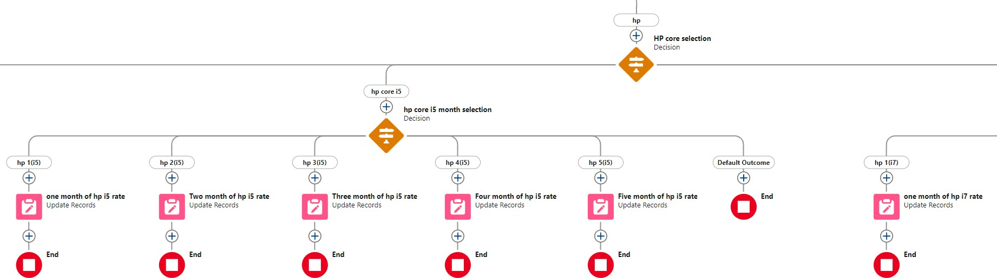

#### Creating A Flow on Mac laptop

* + 1. Beside mac there is a symbol ‘+’ click on that.
    2. Enter the Details Label: mac should be Updated, API name: Gets Automatically Generated.
    3. Select the Outcome Details Label: mac laptop , Outcome API name: Gets Automatically Generated.
* Resource: Select Record.core type.
* Operator: Select Equals.
* Value: Select Bionic Chip.
  + 1. Enter the Details Label:Mac months selected , API name: Gets Automatically Generated.
    2. Enter the Outcome Details Label: mac bionic chip(1) , Outcome API name: Gets Automatically Generated.
* Resource: Select Record.how many months.
* Operator: Select Equals.
* Value: 1.
  + 1. Similarly Create Outcome Details Labels: mac bionic chip(2),mac bionic chip(3), mac bionic chip(4), mac bionic chip(5)
    2. Enter the Details Label: one month of mac rate , API name: Gets Automatically Generated.
    3. Field:- Amount c , value:- for one month of mac bionic chip rate- 1700, two month of mac bionic chip rate-3400, three month of mac bionic chip rate-5100, four month of mac bionic chip rate-6800, five month of mac bionic chip rate-8500. Follow for all these finally and click done.

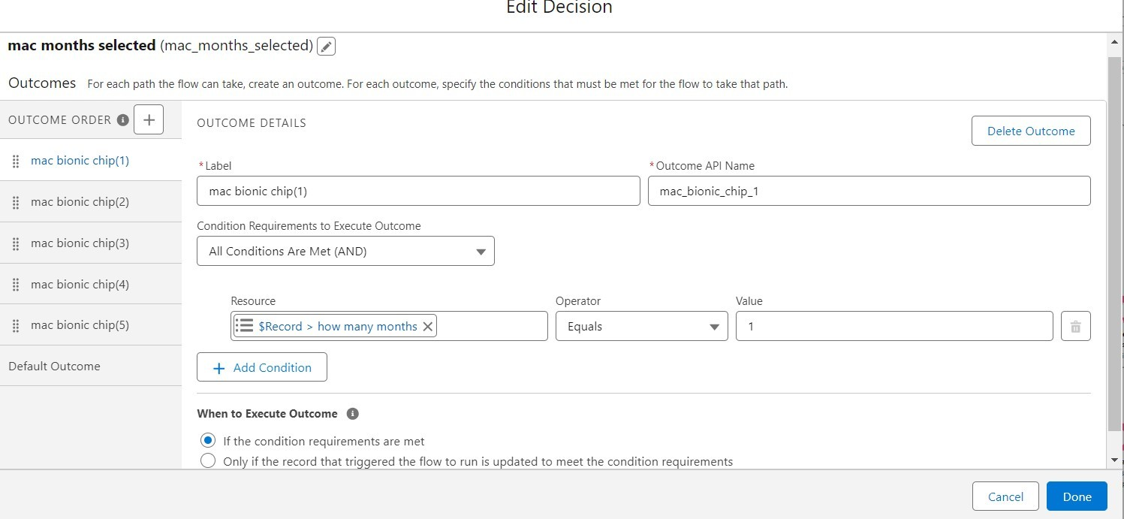

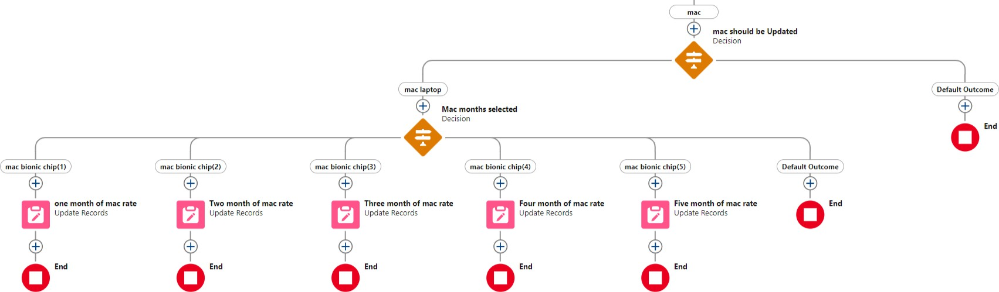

## Apex Trigger and Handler Class

#### Apex

Apex is a strongly typed, object-oriented programming language that allows developers to **execute flow** and **transaction control statements** on the Lightning platform server in conjunction with calls to the Lightning Platform API. It is as similar as java i.e, it also supports OOP( Object oriented programming) like Classes, objects, methods.

#### Trigger

A trigger is a set of Apex code that runs before or after DML(Data Manipulation Language) events. A DML event could be a variety of data processing tasks that include the standard insert, update, and delete commands. With Apex triggers, you can automate tasks that would otherwise be nearly impossible to accomplish using only the Salesforce user interface.

There are two Salesforce Apex trigger types:

1. Before Triggers 2. After triggers

#### Create a new trigger:

* 1. Click on developer console and you will be navigated to a new console window.
  2. Click on the File menu in the toolbar, and click on new Trigger.

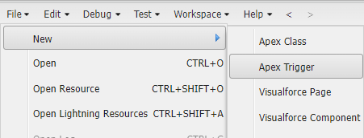

* 1. Enter the trigger name and the object to be triggered.

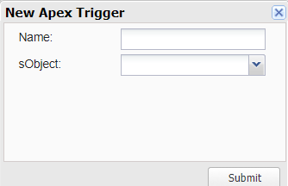

#### To Create Laptop Booking Trigger

**Purpose**: This trigger is called whenever the particular record's sum exceeds the threshold i.e minimum business requirement value. Then the code in the trigger will get executed.

#### Trigger Code:

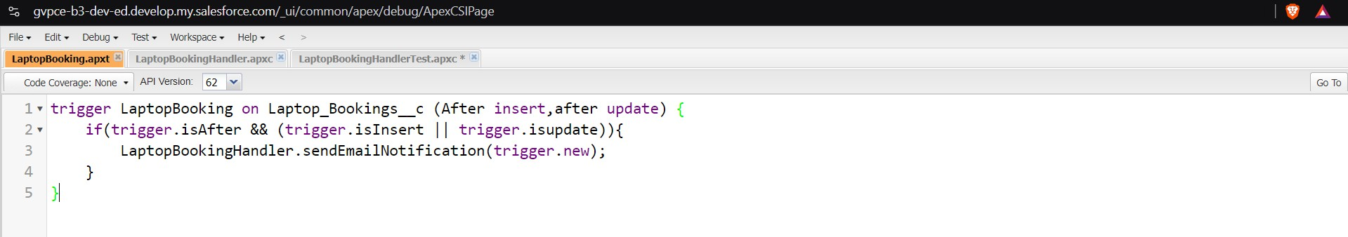

* 1. **Create Handler Class**

**Purpose:** In LaptopBookingHandler class, sendEmailNotification method is defined which automates sending email with the details like laptop type, core type, amount when a customer books laptops

#### Code:

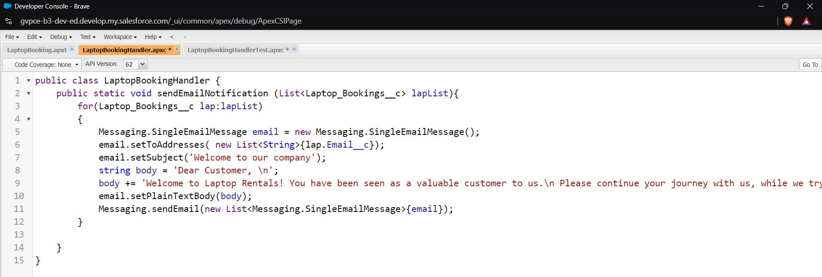

The output:

## Reports

Reports give you access to your Salesforce data. It displays it in easy-to- understand formats, and share the resulting insights with others. Before building, reading, and sharing reports, review these reporting basics.

#### Types of Reports in Salesforce:

* Tabular
* Summary
* Matrix
* Joined Reports

#### Create Report

* + 1. Go to the app "Laptop Rentals".
    2. click on the reports tab and Click New Report.
    3. Select report type from category and click on start report.
    4. Create a simple tabular report
    5. Add fields from left pane, make sure that Amount field will be selected.
    6. Click the Amount column drop down and select bucket list.

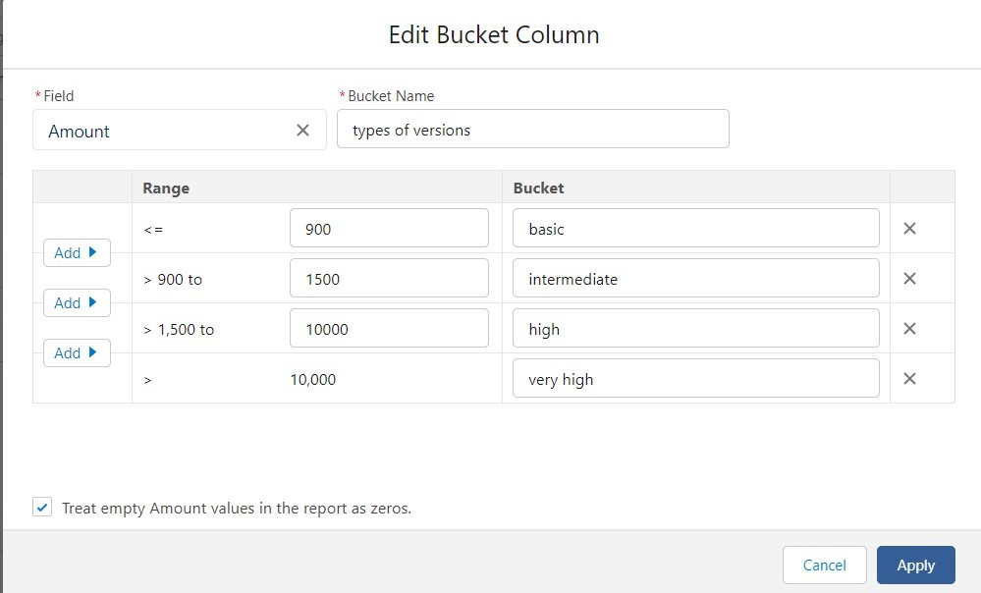

* + 1. Select Types of version in Group By Rows to create a summary report.
    2. Click on Save & run it.

#### Report output:

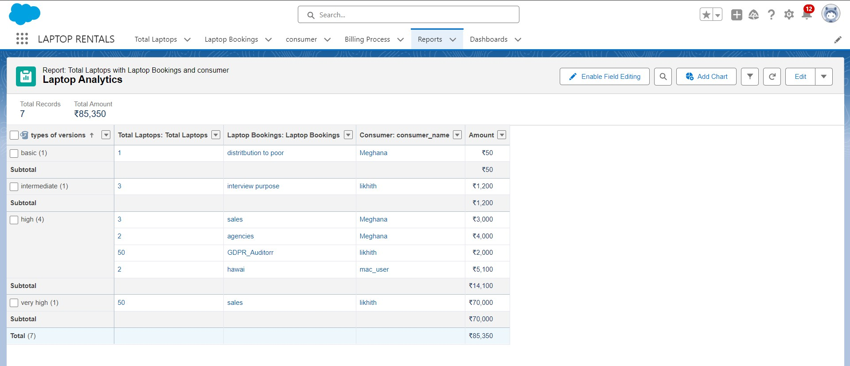

* 1. **Sharing Report To Owner**
     1. Click edit drop down and select subscribe option

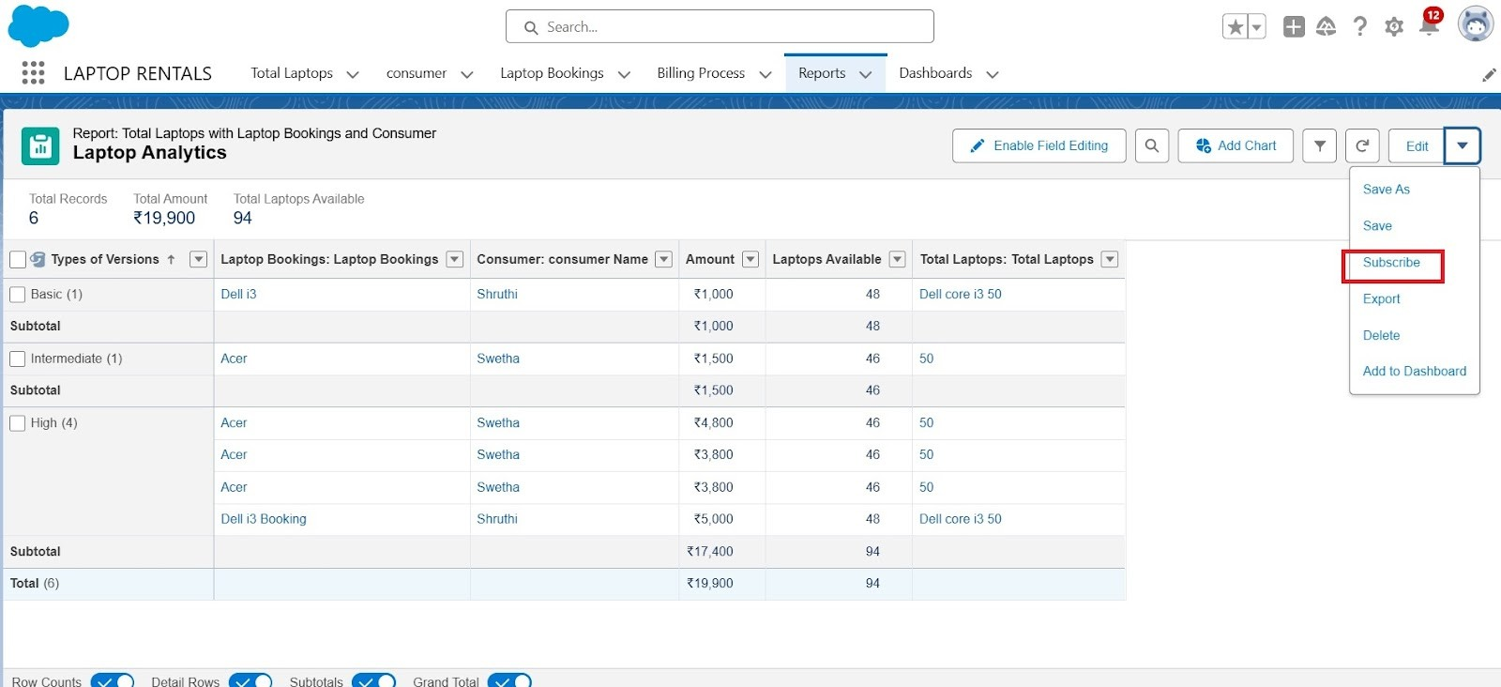

* + 1. Fill the details like frequency, time, mail to whom the report has to be sent.

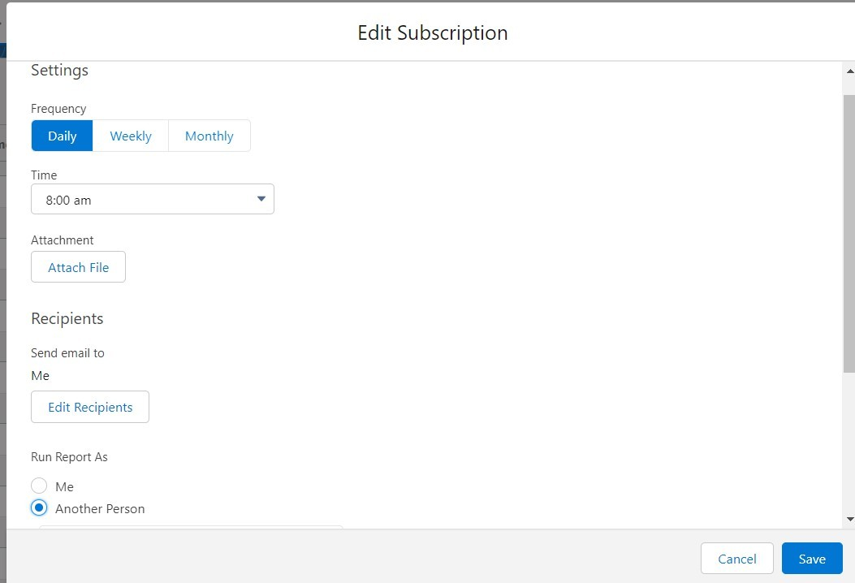

* + 1. After selecting the run report as a “another person” select your personal account or whom you want to send that mail to.
    2. Click save.

The report being sent to mail looks like:

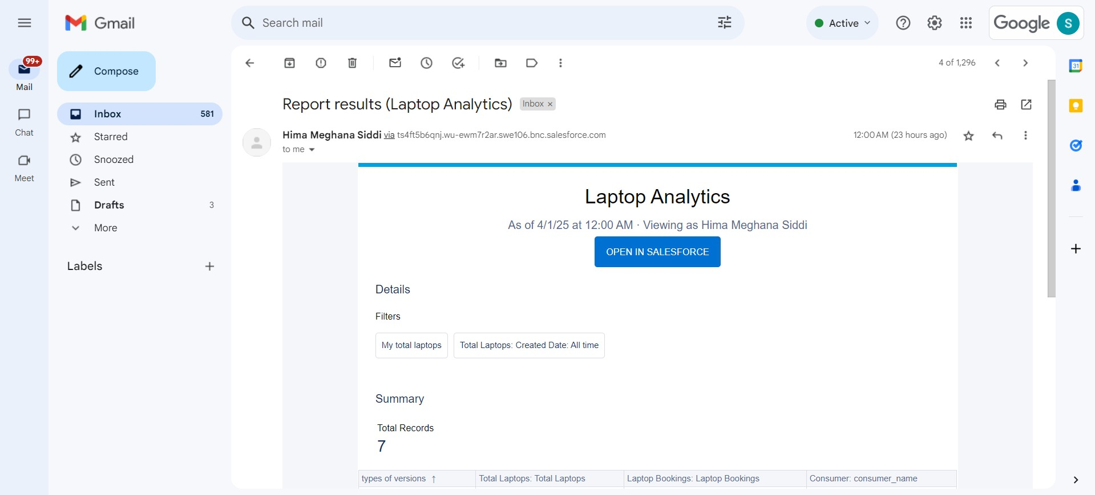

## Dashboards

Dashboards help you visually understand changing business conditions so you can make decisions based on the real-time data you’ve gathered with reports. Use dashboards to help users **identify trends**, sort out quantities, and measure the impact of their activities.

#### Create Dashboard folder

* + 1. Click on the app launcher and search for the dashboard.
    2. Click on the dashboard tab.
    3. Click the new folder, give the folder label as “total rent amount”.
    4. Folder unique names will be auto populated.
    5. Click save.

#### Create Dashboard

* + 1. Go to the app >> click on the Dashboards tabs.

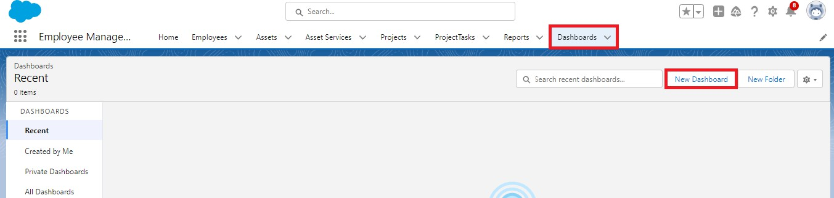

* + 1. Give a Name and select the folder that was created, and click on create.

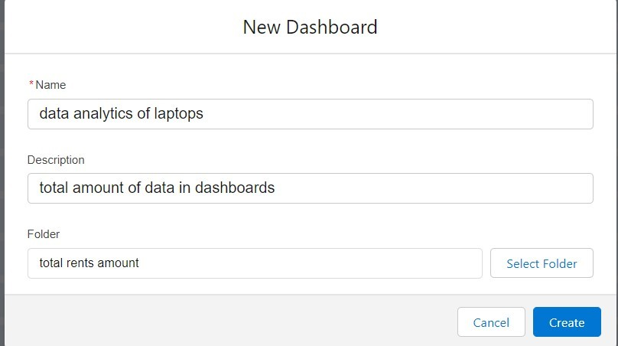

* + 1. Select add component.
    2. Select a Report and click on select.
    3. Select the dark component and add to the dashboards.
    4. Save it and Click done.

**Dashboard output:**

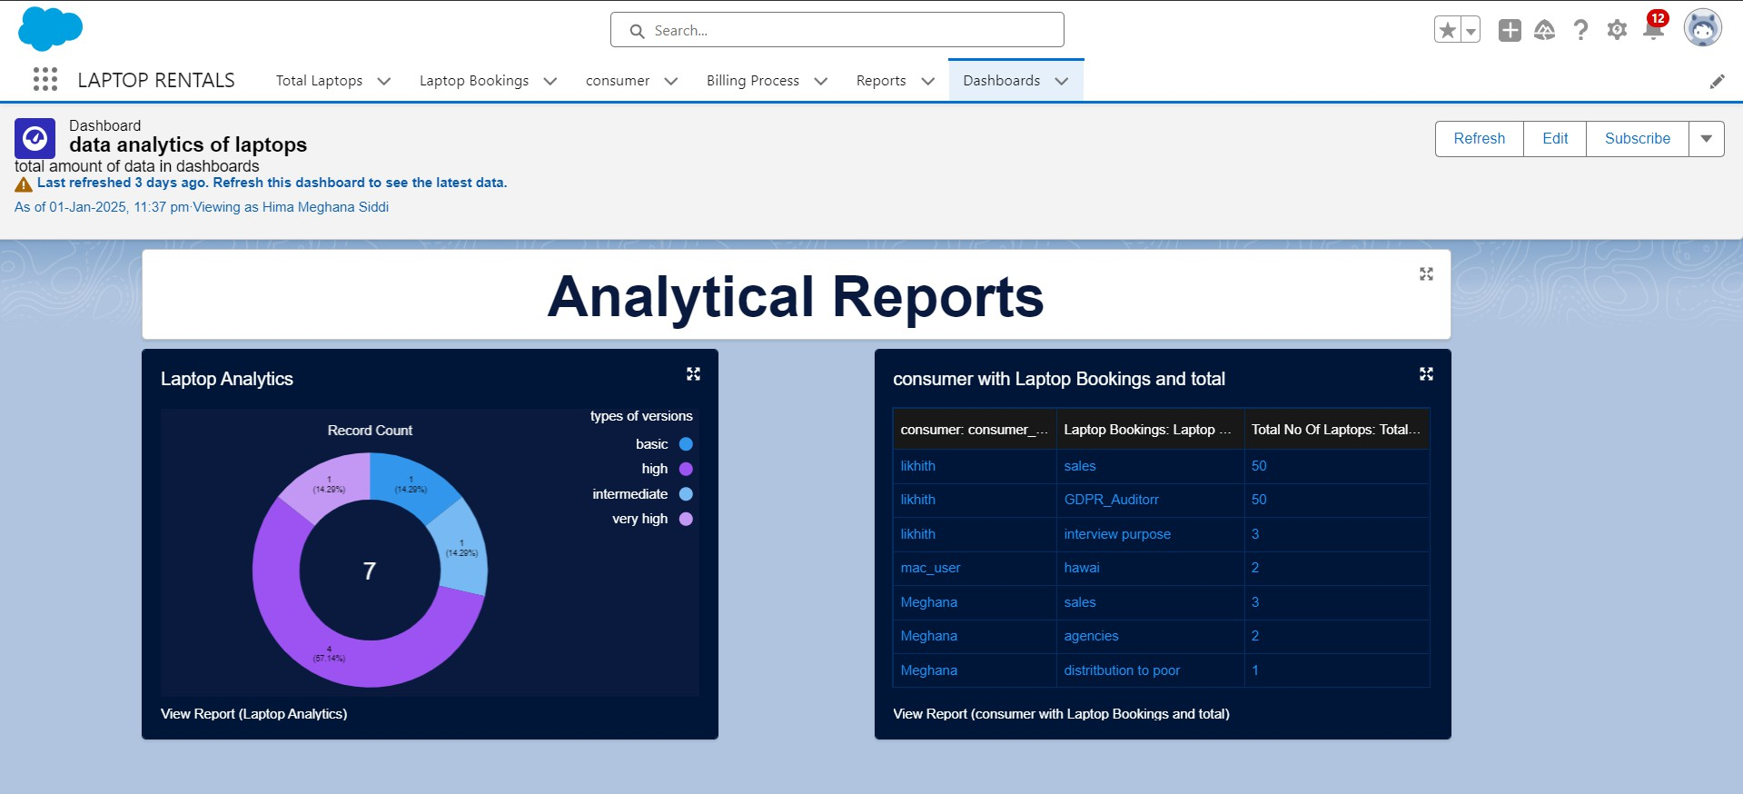

1. **Testing and Validation**
   1. **Unit Testing**

Testing the Laptop Booking Handler class

#### LaptopBookingHandlerTest.apxc code snippet:

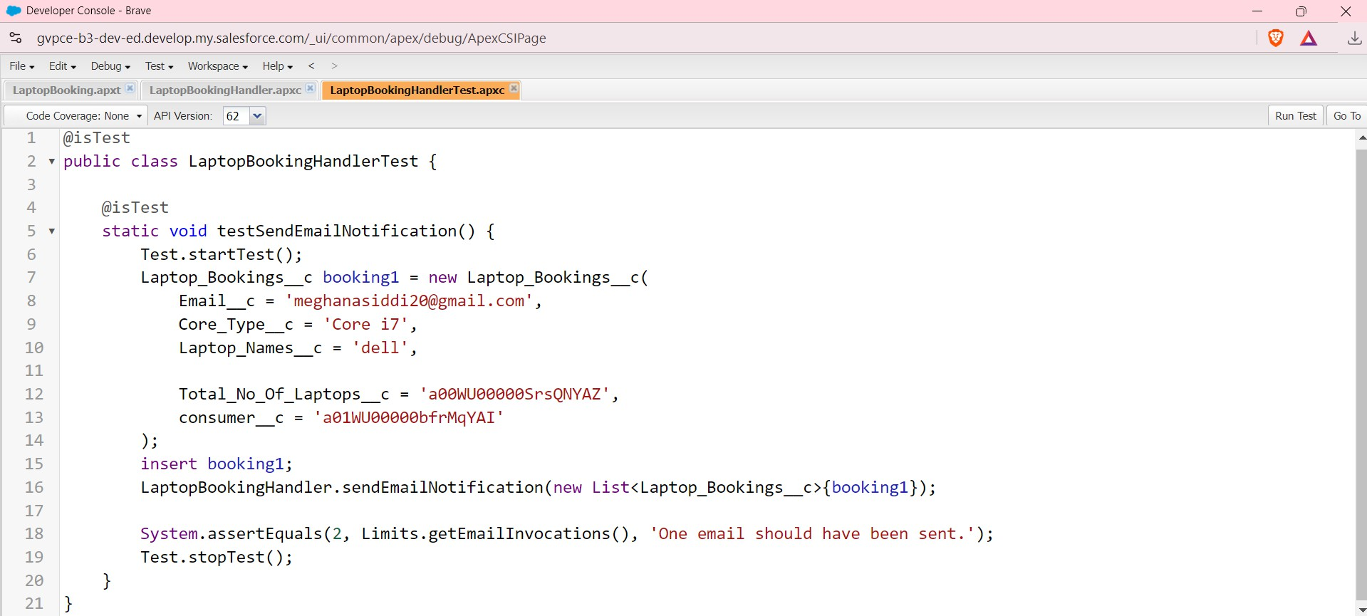

Output:

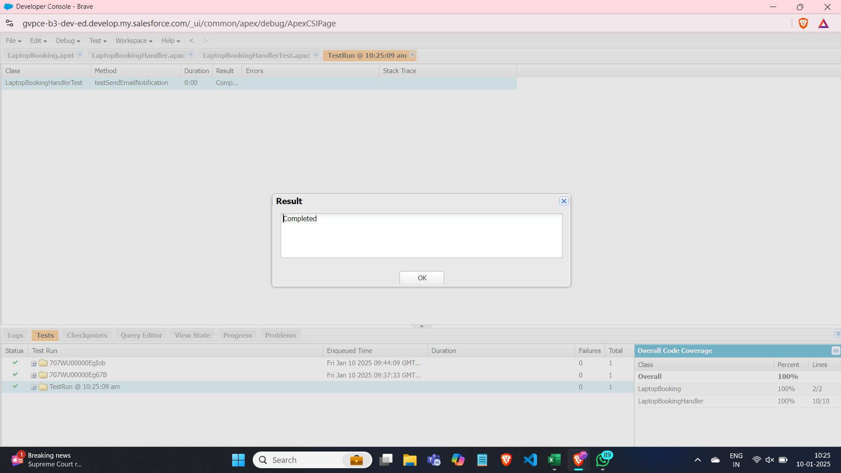

Overall code coverage is 100%

#### Explanation:

**"System.assertEquals"** is a method in Salesforce's Apex programming language, used for unit testing. It helps verify that the expected value matches the actual value produced by your code

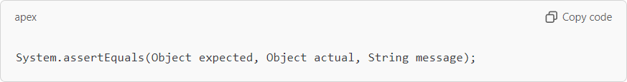

This test is successfully completed indicating all functionalities working good.

#### Validation

I observed that

* + - In Consumer, Laptopbookings, Total Laptops objects, the required fields are set up and if when creating records, if any required field is not entered, then it throws an error like

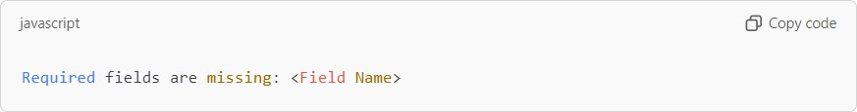

* + - It is verified when creating Laptop bookings object and missed a field, then the output is
    - The validation rule "Phonenumberoremailblankrule" in consumer object ensures that at least one of the fields, phone_number c or email c, is filled when creating or updating a record in the Consumer object.

If both fields are left blank, the rule prevents the record from being saved and displays an error message.

It displayed the message “phone number and email number should not be blank”

## Key Scenarios Addressed by Salesforce in Implementation Of The Project

* **Customer Relationship Management (CRM)**: Salesforce handles managing and analyzing customer interactions and data, improving customer service and engagement.

### **Sales Process Automation**: It automates various sales processes, like tracking leads, opportunities, and performance, helping sales teams close deals faster.

* **Marketing Campaigns and Engagement**: Salesforce enables personalized marketing campaigns and provides tools for tracking and analyzing their effectiveness.

### **Service Management**: It supports case management, service cloud, and provides tools for customer support teams to resolve issues eciently.

* **Analytics and Reporting**: Salesforce helps generate real-time reports and dashboards, providing insights into business operations and customer behavior.
* **Collaboration and Integration**: The platform ensures streamlined workflows and improved productivity.

# Conclusion

The **Laptop Rental CRM** has successfully created a digital platform to streamline the entire laptop rental process. By implementing real-time tracking, efficient coordination of rentals, and a user-friendly interface, the CRM has improved the efficiency and effectiveness of laptop rental operations. Key milestones include integrating online booking, automating payment processing, and developing tools for inventory management and customer relationship management. With this project, we have taken a step toward optimizing the rental process, enhancing customer satisfaction, and increasing the profitability of the laptop rental business.